**ASSIGNMENT 2 ESWAR VARDHAN**

**A0000076347**

**PART 1: Setup EC2, TG and LB**

1. Opened the AWS EC2 and changed the region to **N Virginia.**

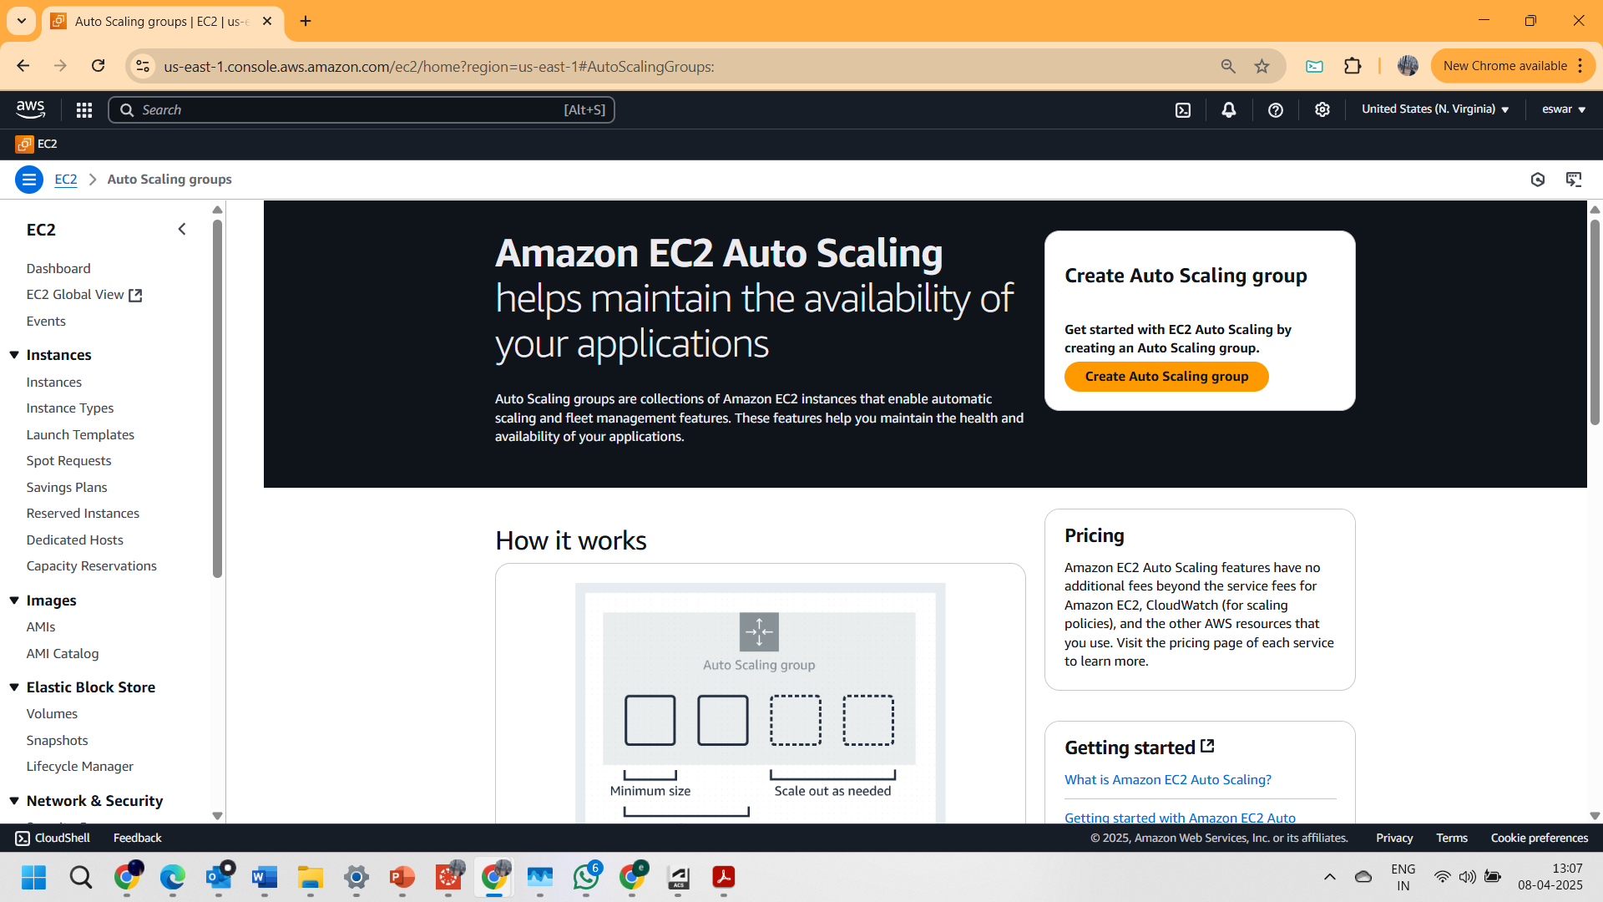

2.Updated the new tag with value **“httpserver1” shown below**

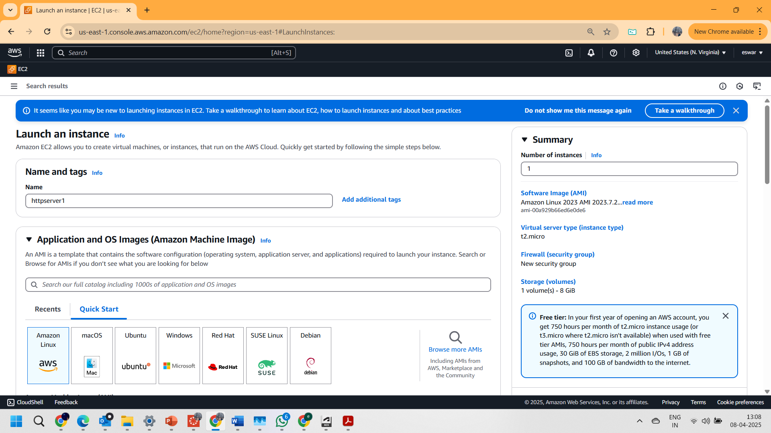

3. Chosen the **AMAZON LINUX AMI** image as OS

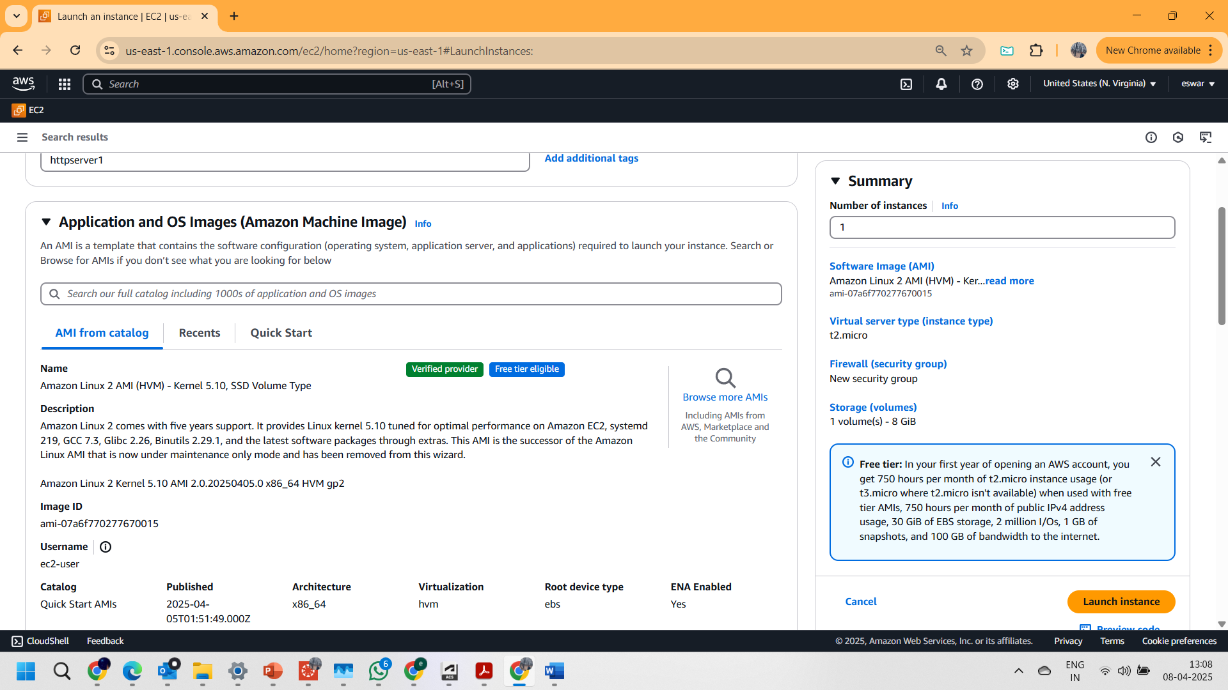

4.Ensuring the instance type is **t2.micro**

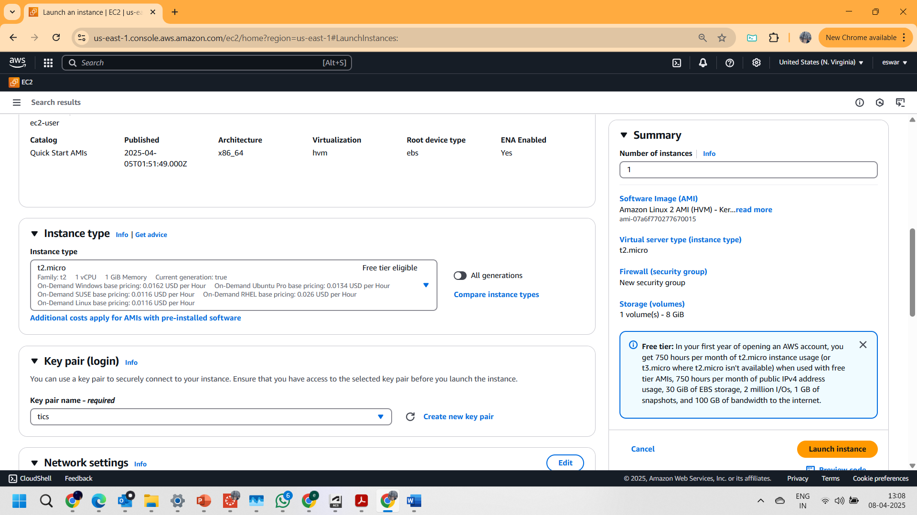

5.Downloaded the key pair for login (**tics.pem**)

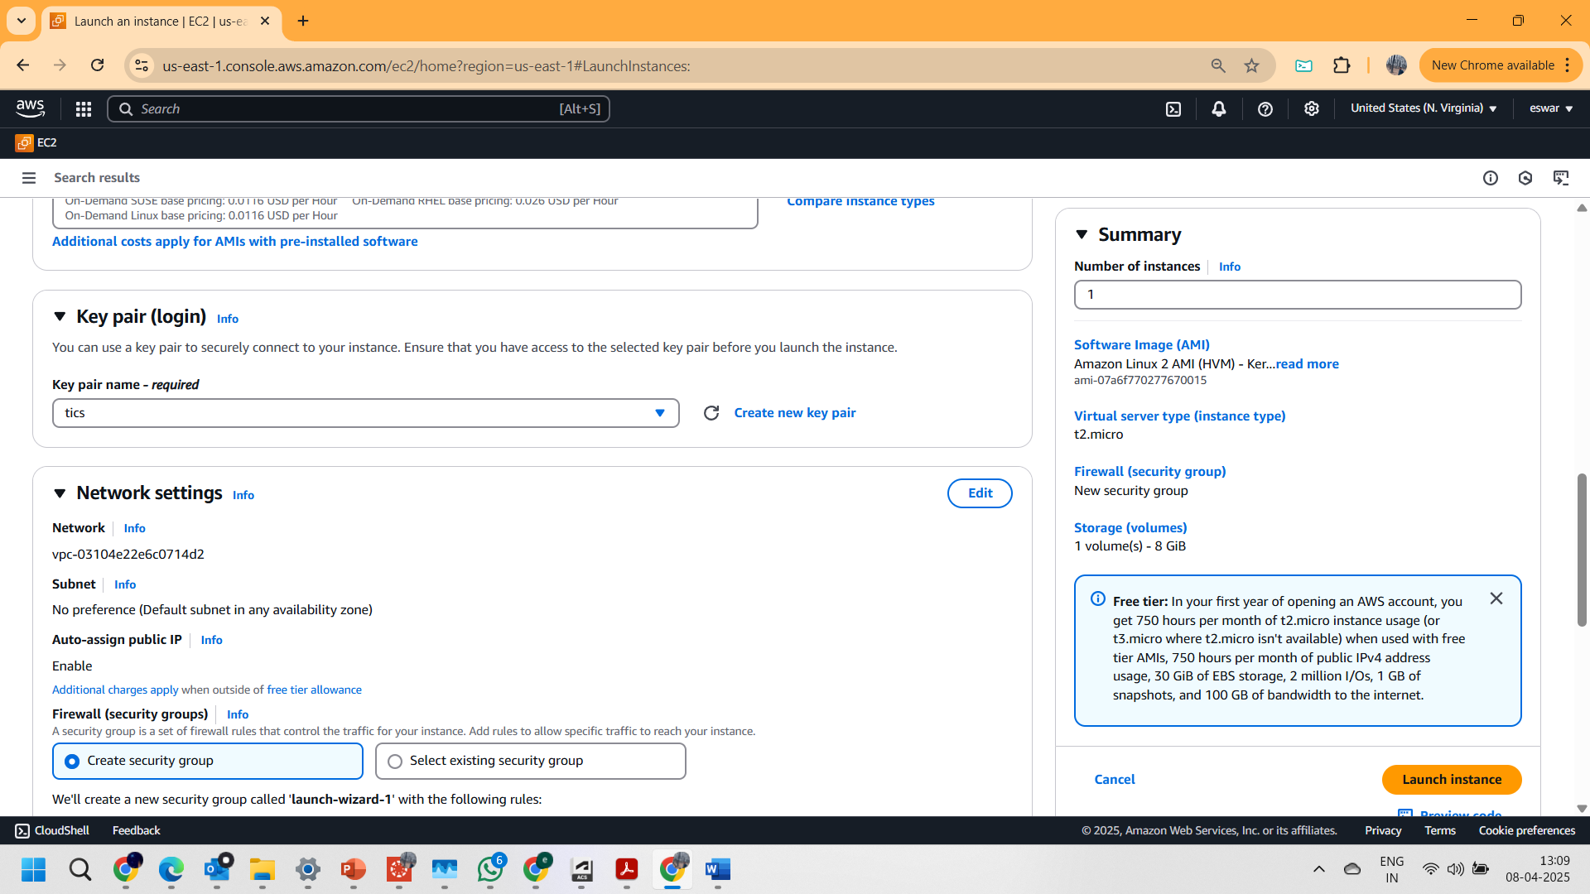

6.In the network settings..

* + Updated the subnet to east us 1a.
  + Enabled auto assign public ip.
  + And added a existing security group “assign 1-sg”.

which opens http port (port:80) from “anywhere”

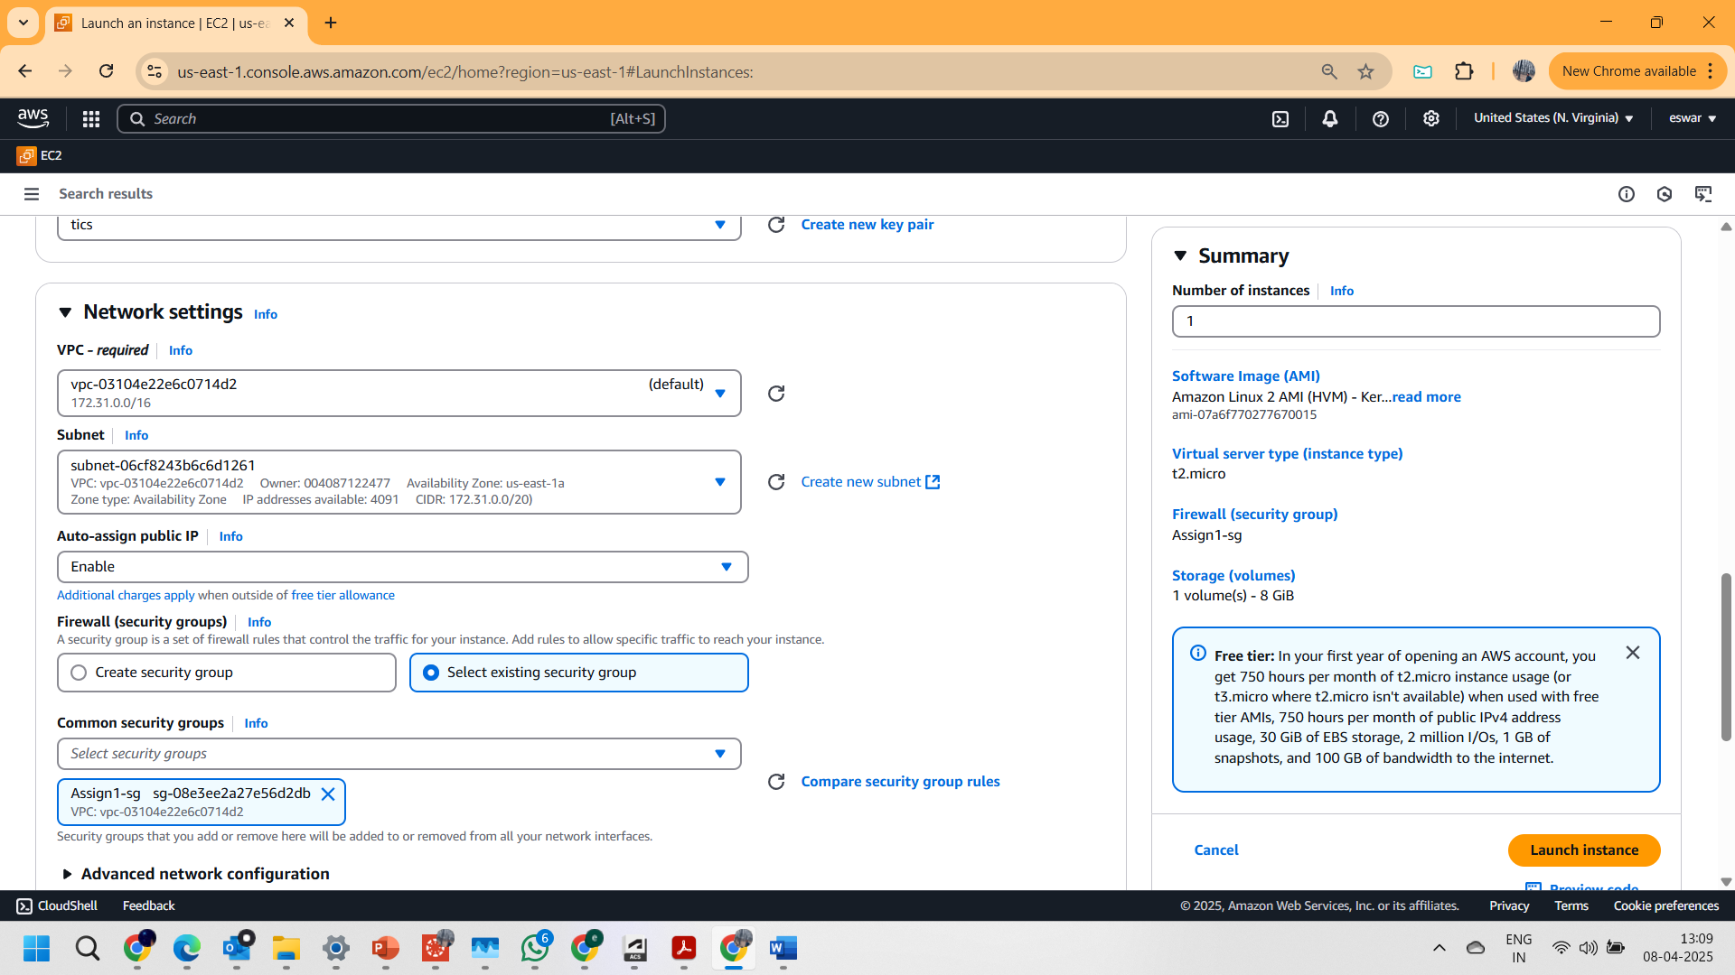

7. Uploaded the bash script as seen below in the

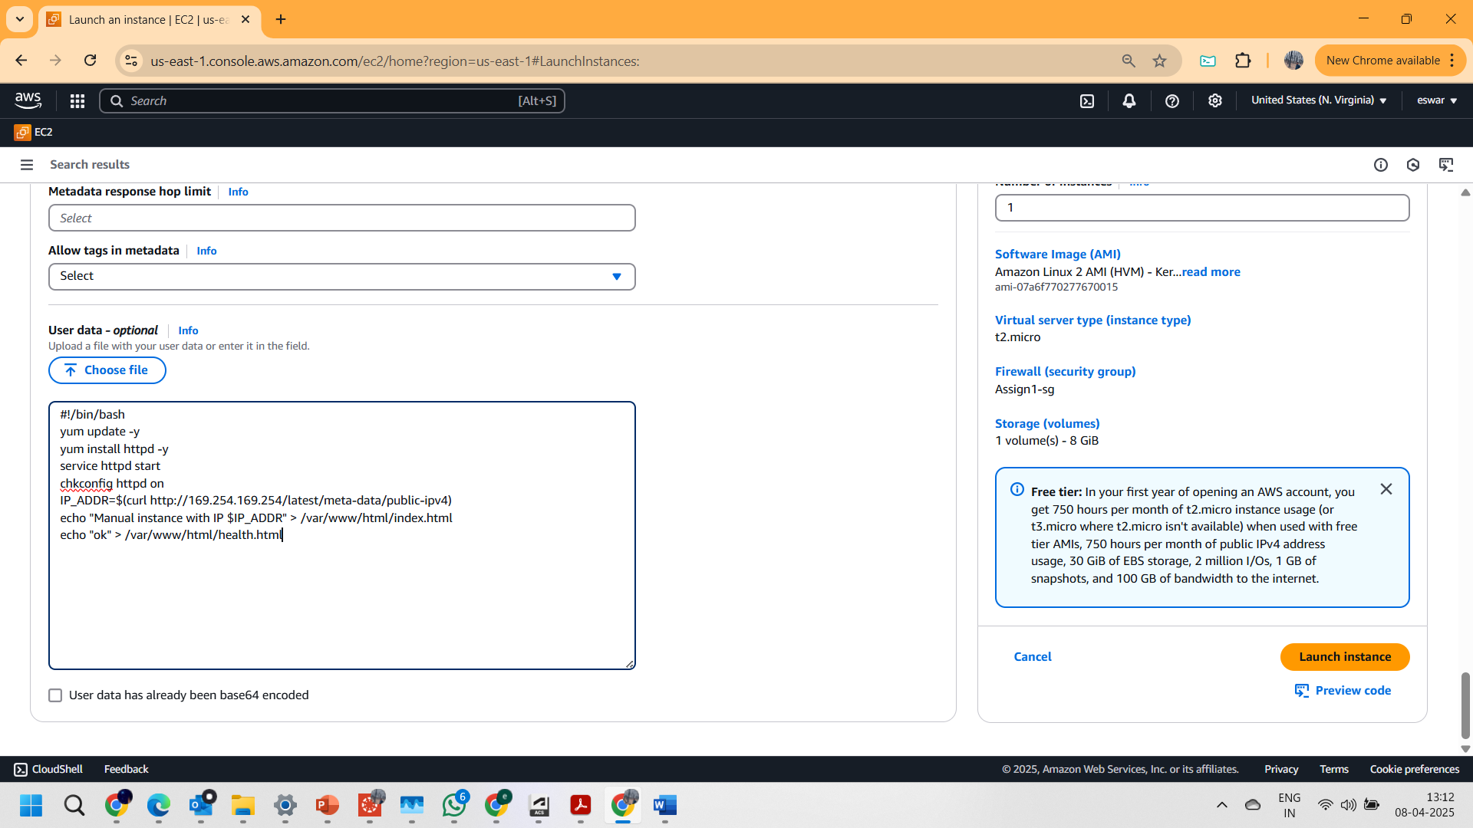

8. And launched the instance successfully.

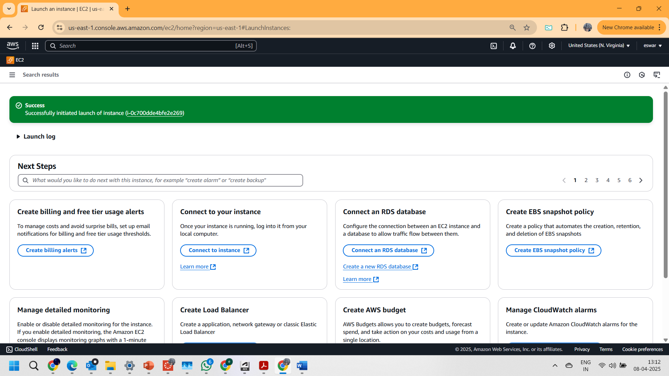

9. And in the instances checked on the instance “httpserver1” and copied the ip address

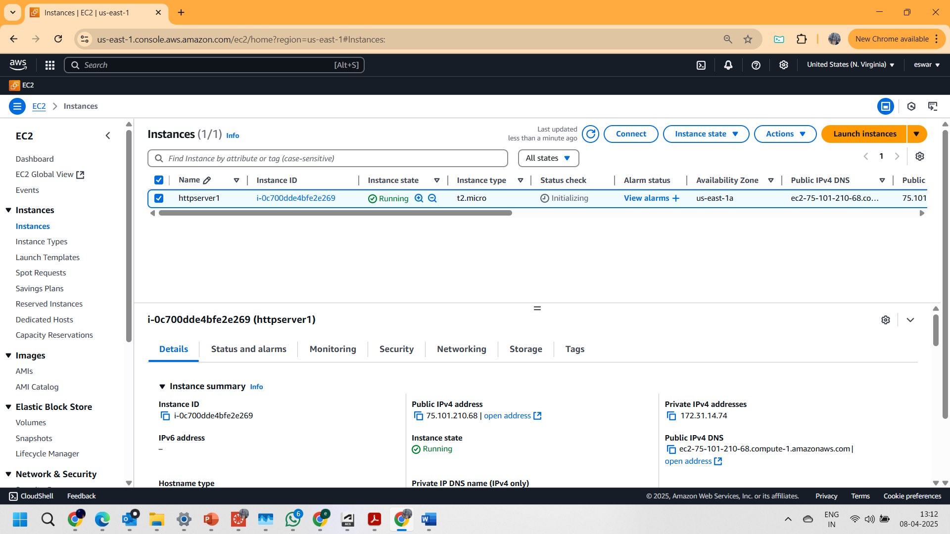

10. successfully the Ip address browsed and the required web page has been viewed as seen below

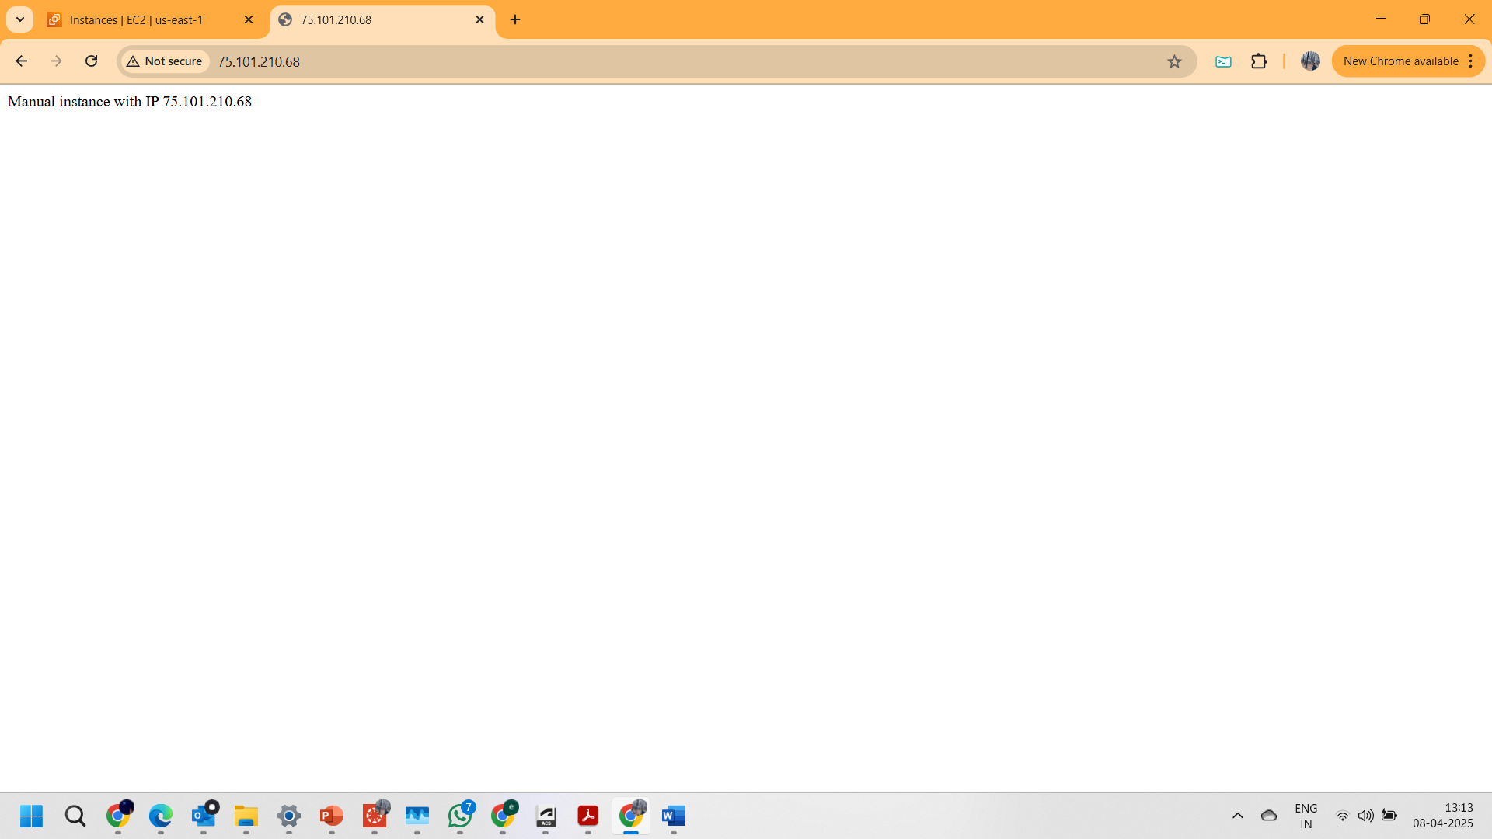

**PART 1.1: Launching an 2nd instance**

1. Created another instance with key value as **httpserver2** this will help to differentiate from previous instance

2. httpserver2 is deployed in **us-east-1b zone**

3.And the accessed the Ip address of **2nd instance** and **successfully** retrieved the page shown in 2nd image of this page.

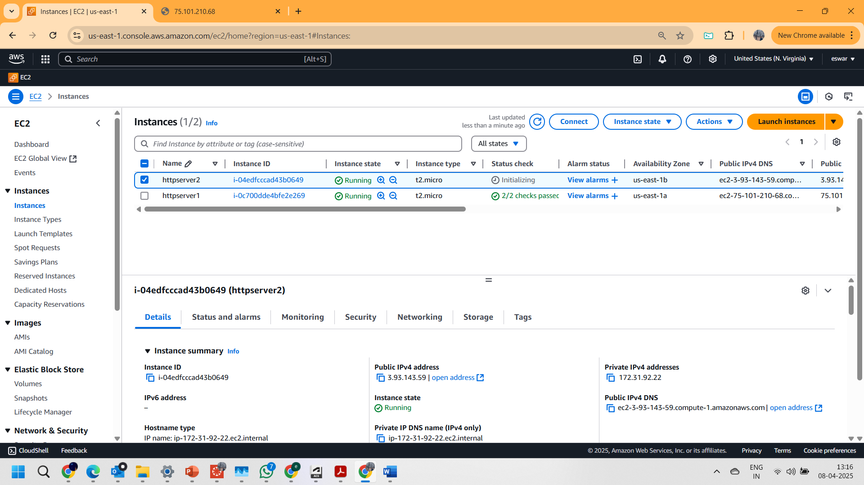

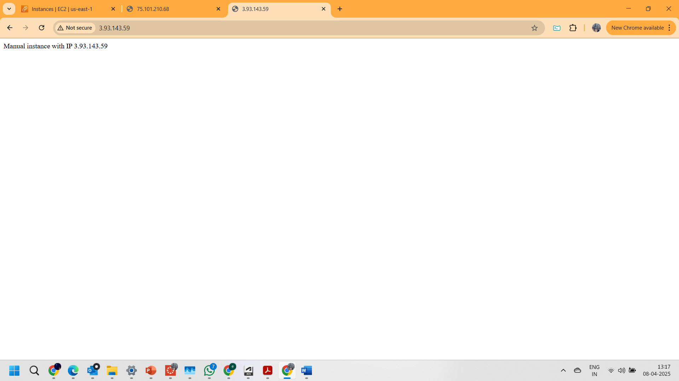

**Part 1.3: TARGET GROUP CREATION**

1.Opened the **TARGET GROUP** Feature under LOAD BALANCER section.

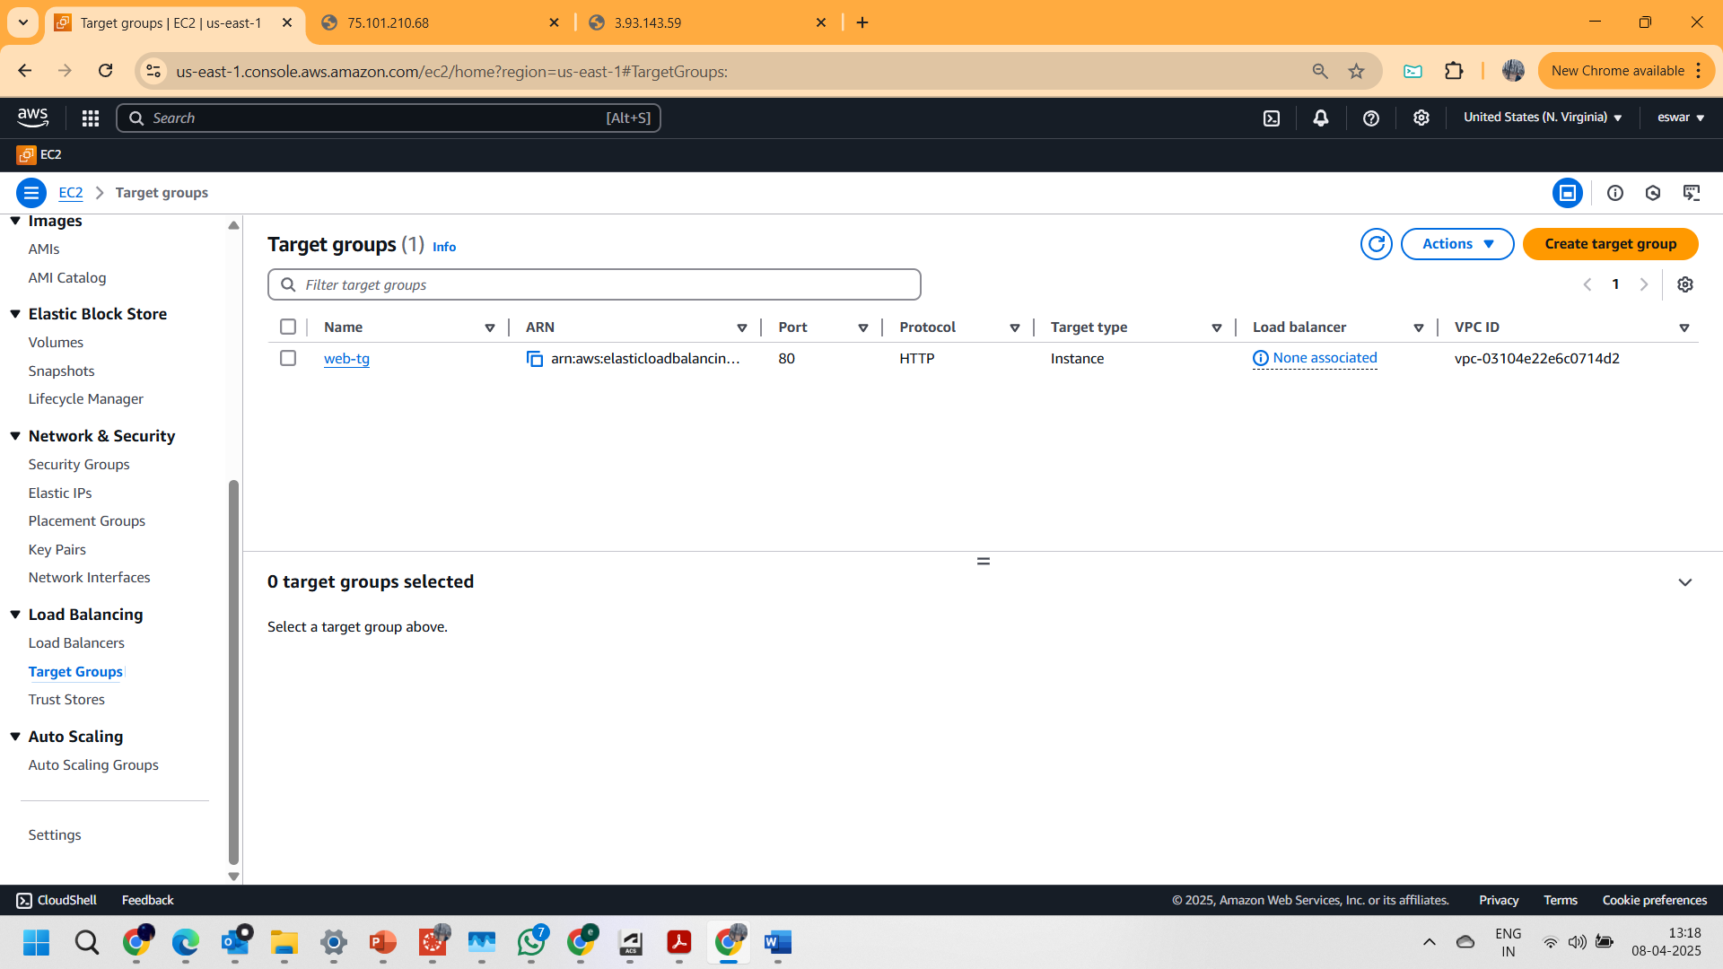

2.And after entering into the **CREATE TARGET GROUP** button on the left top corner.

3. selected **Instances** as Target type.

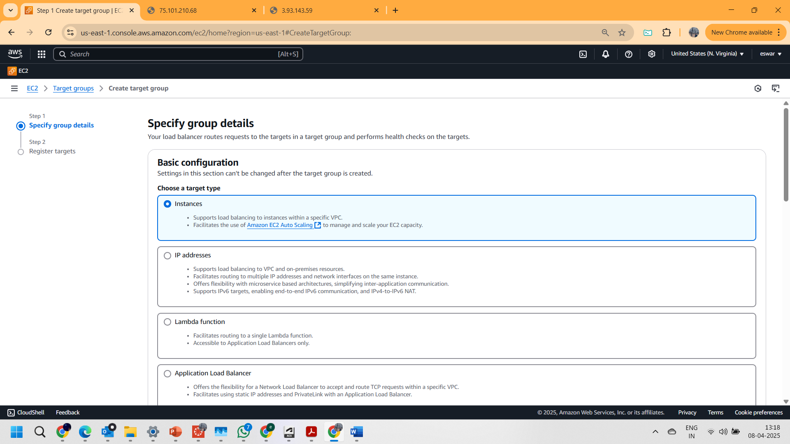

4. Given **web-tg** has Target Group name

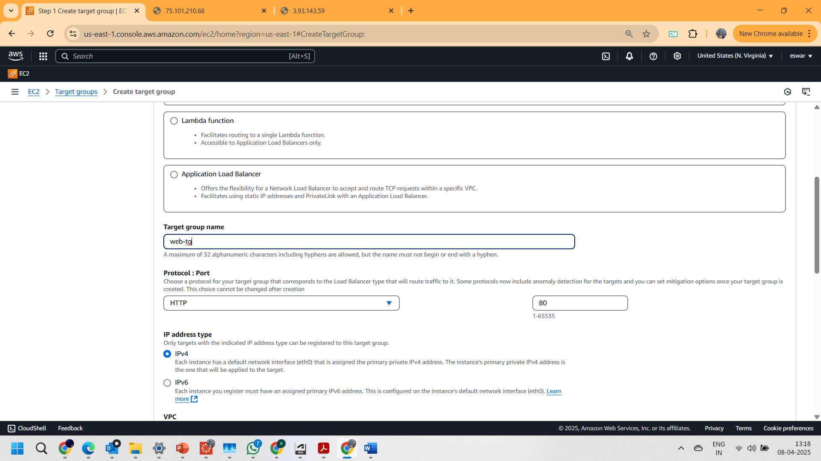

5. In the Health checks card added the “/health.html” text in the Health check path field and also updated the healthy threshold value to “2” from “5”.

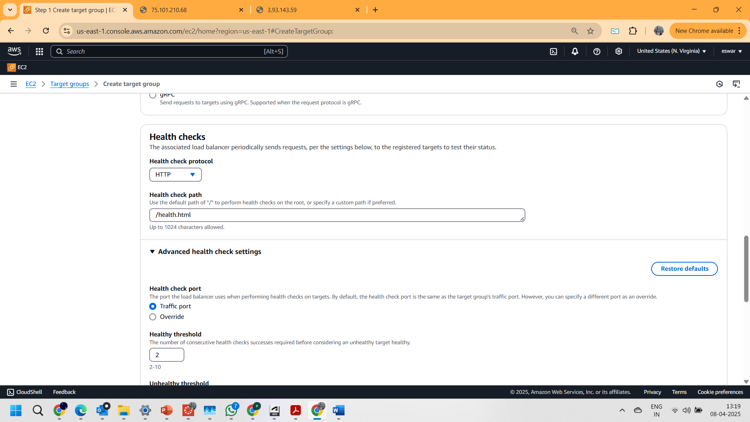

6.And NEXT, Included the two instance as pending below (as shown in below images)

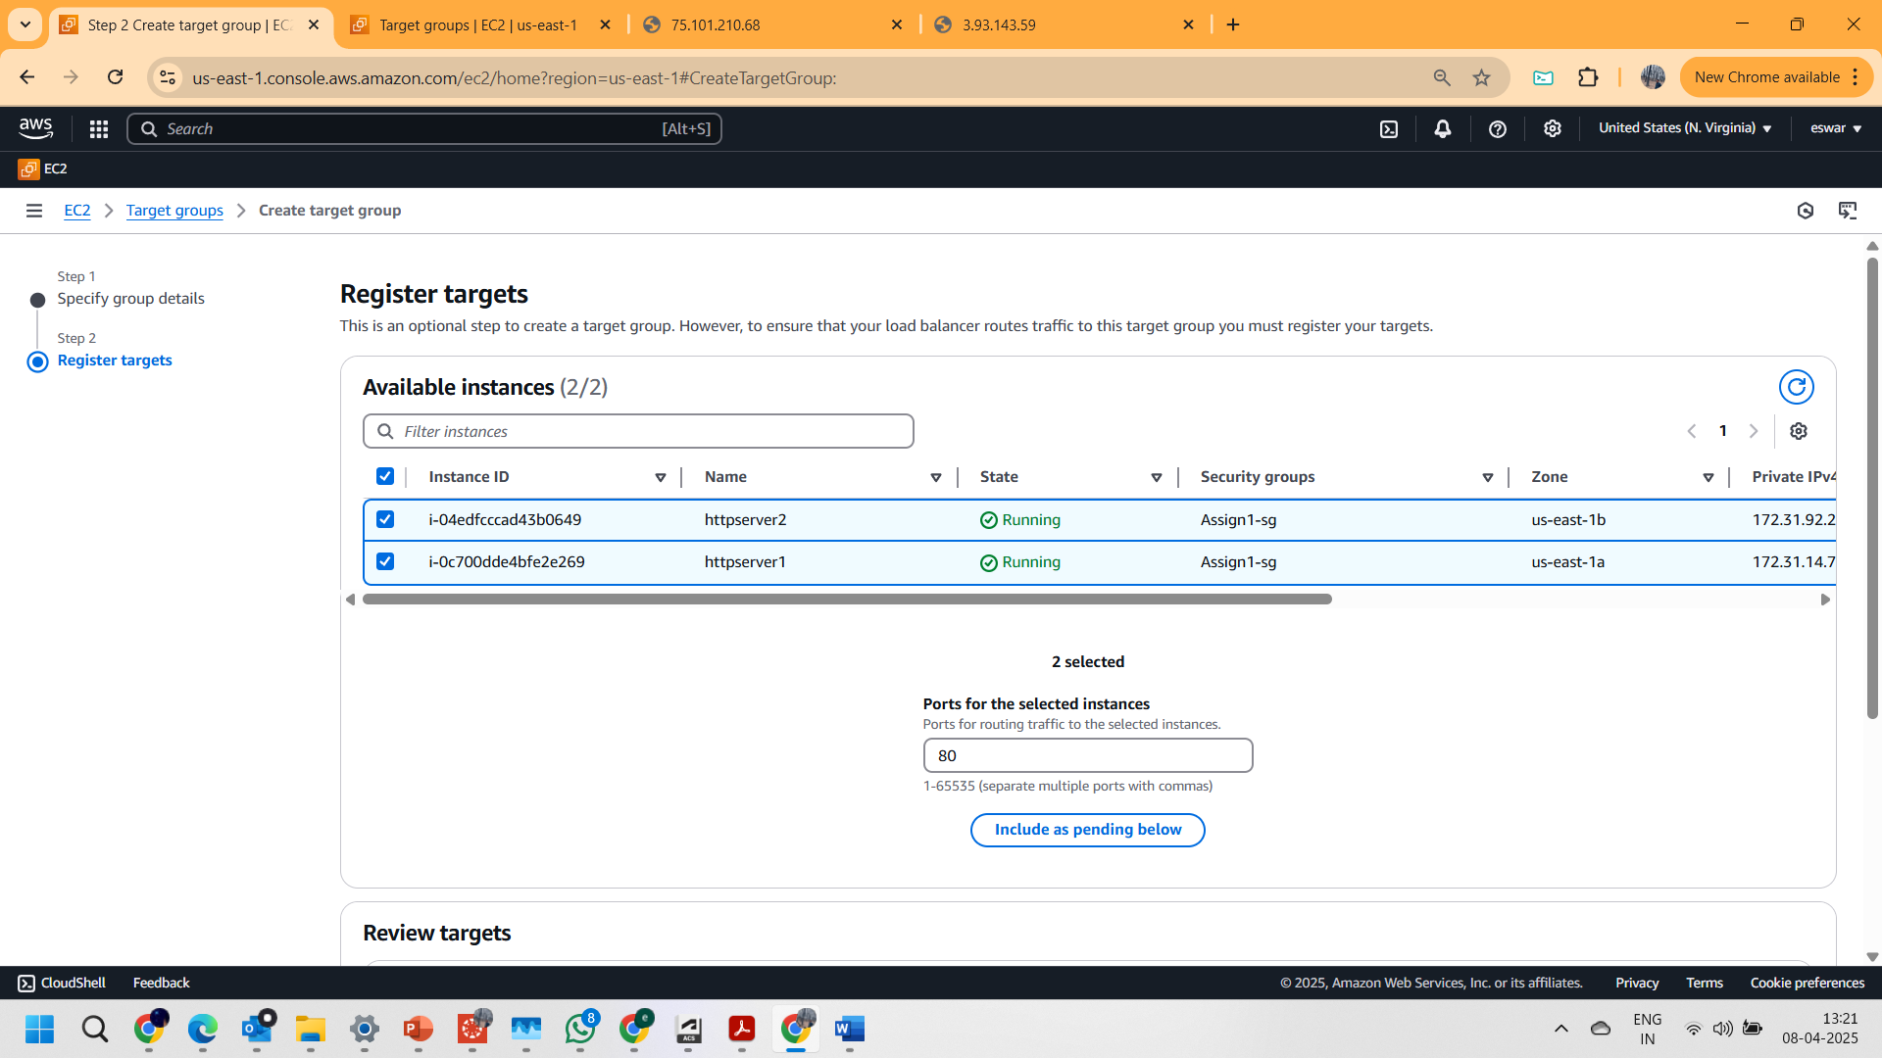

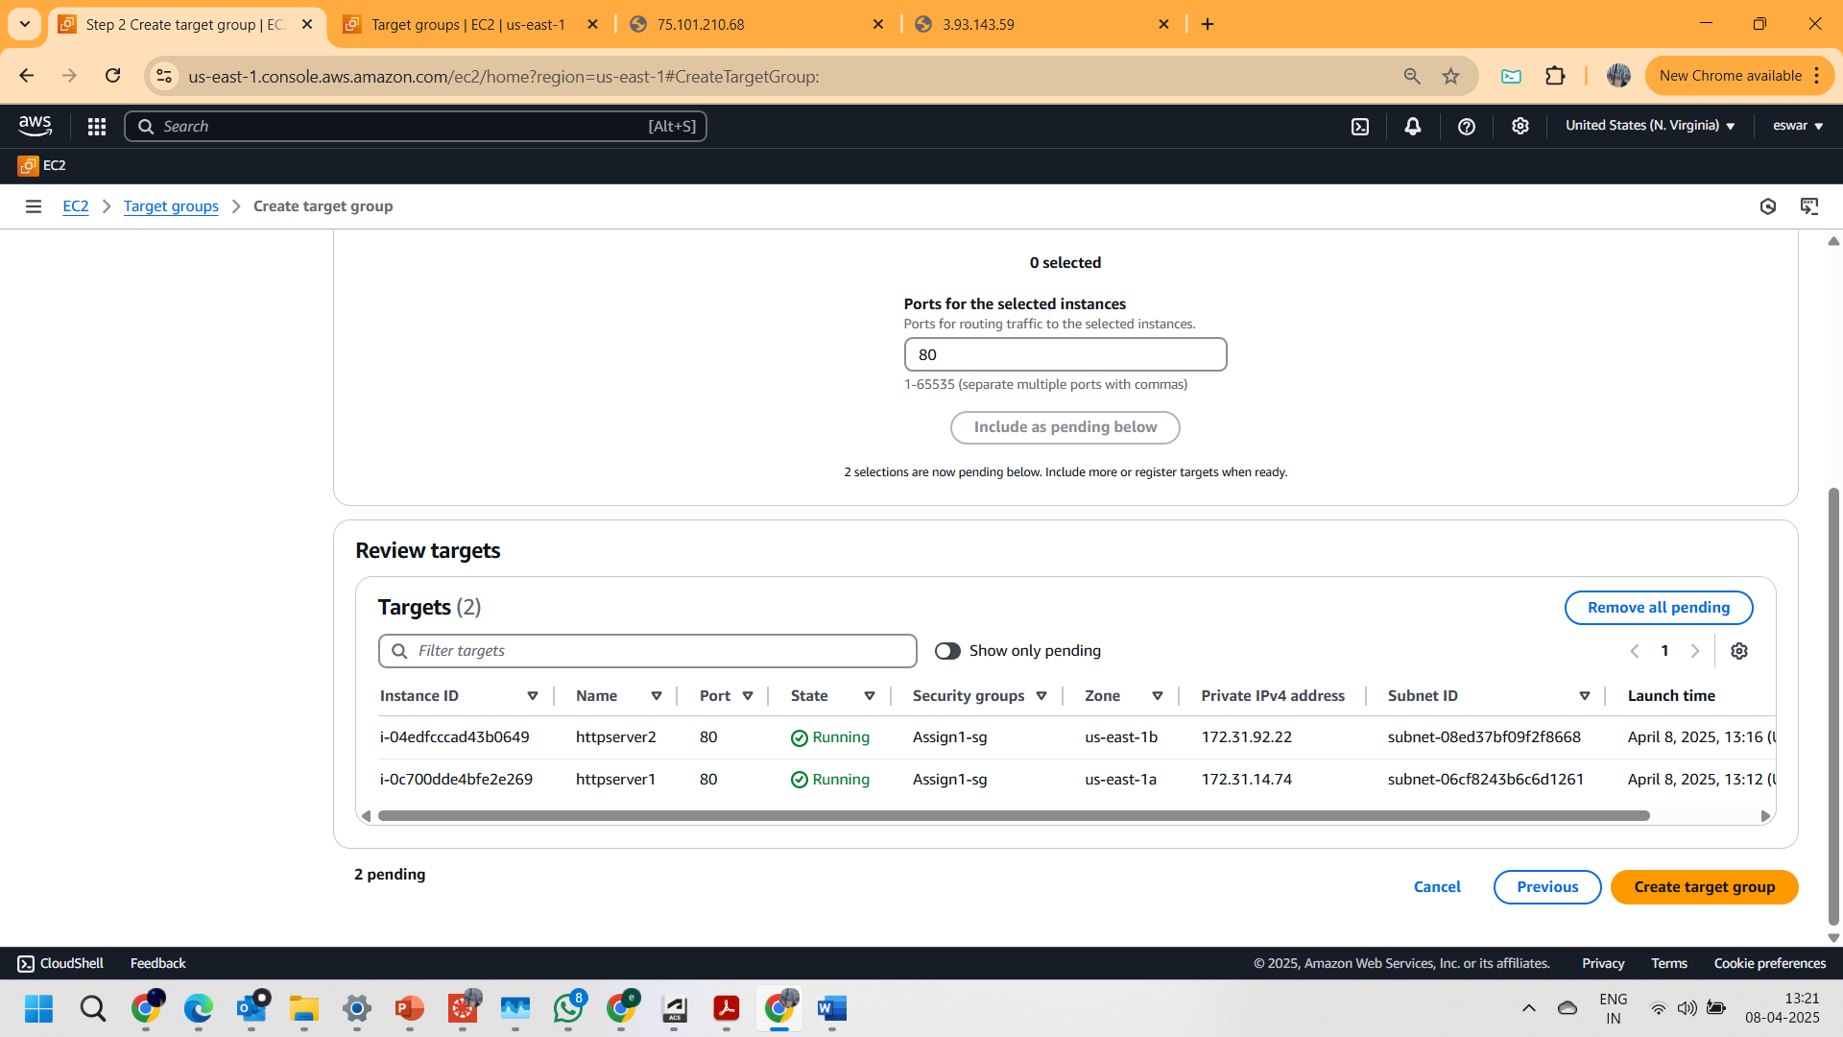

7.And successfully created the **TARGET GROUP** as shown below

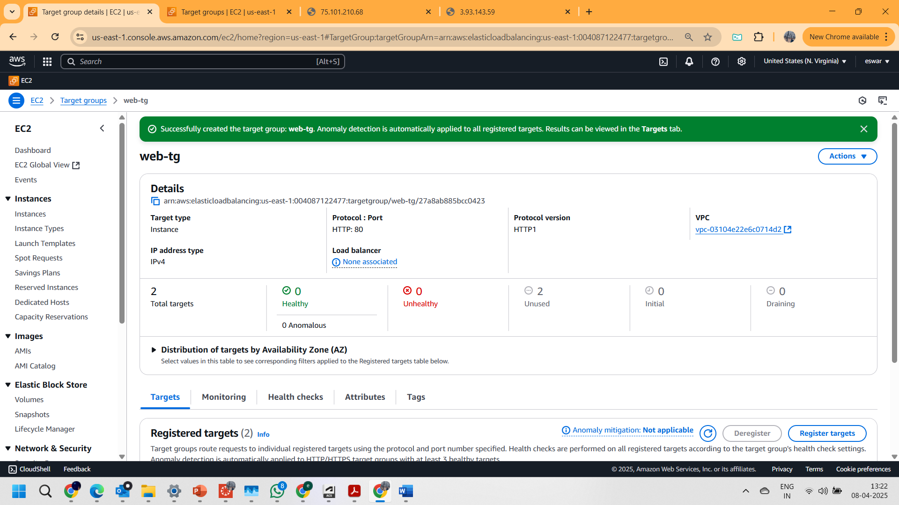

**PART 1.4: Creating an APPLICATION LOAD BALANCER**

1.Landed on the page of load balancer. And clicked on the “create load balancer “button.

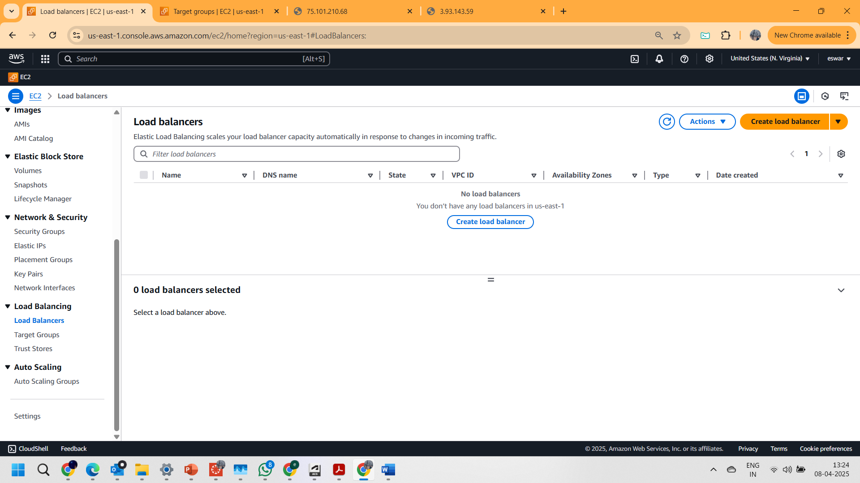

2. Selected the **Application Load Balancer** as Load balancer type.

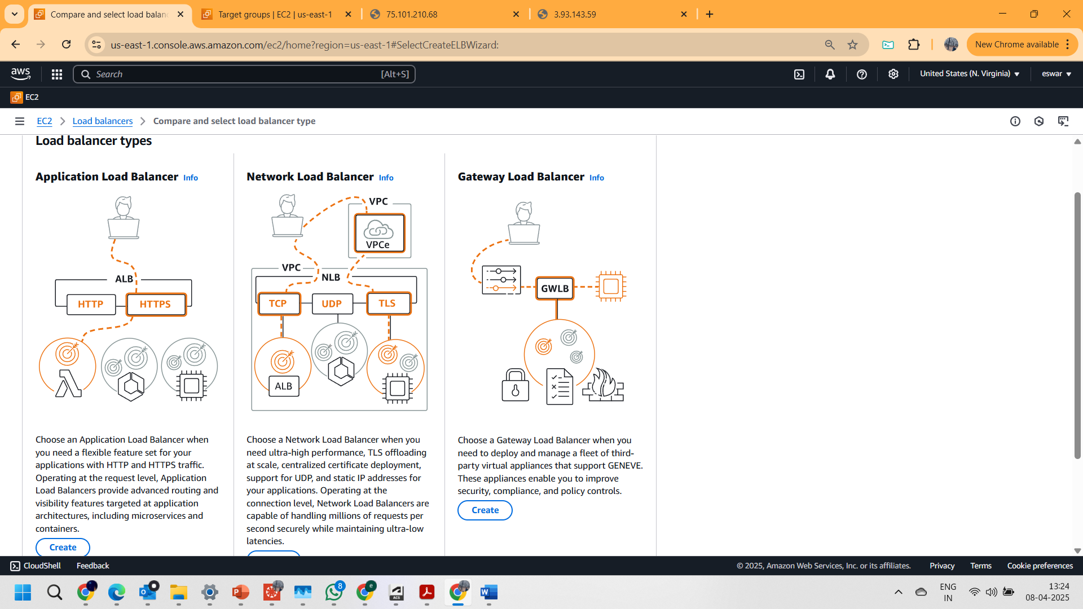

3. Given **web-lb** as Load Balancer name

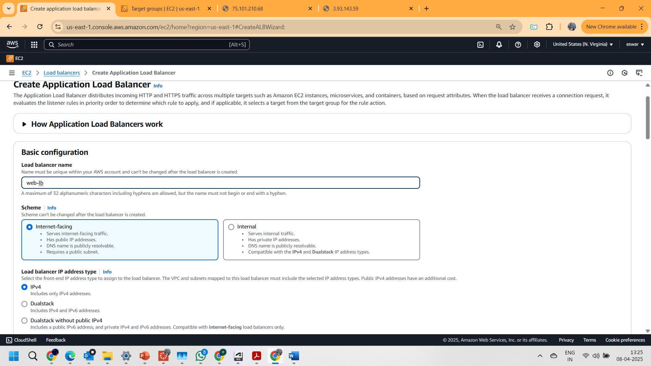

4. And selected all the **zones** and added “**assign-1 sg**” as security group

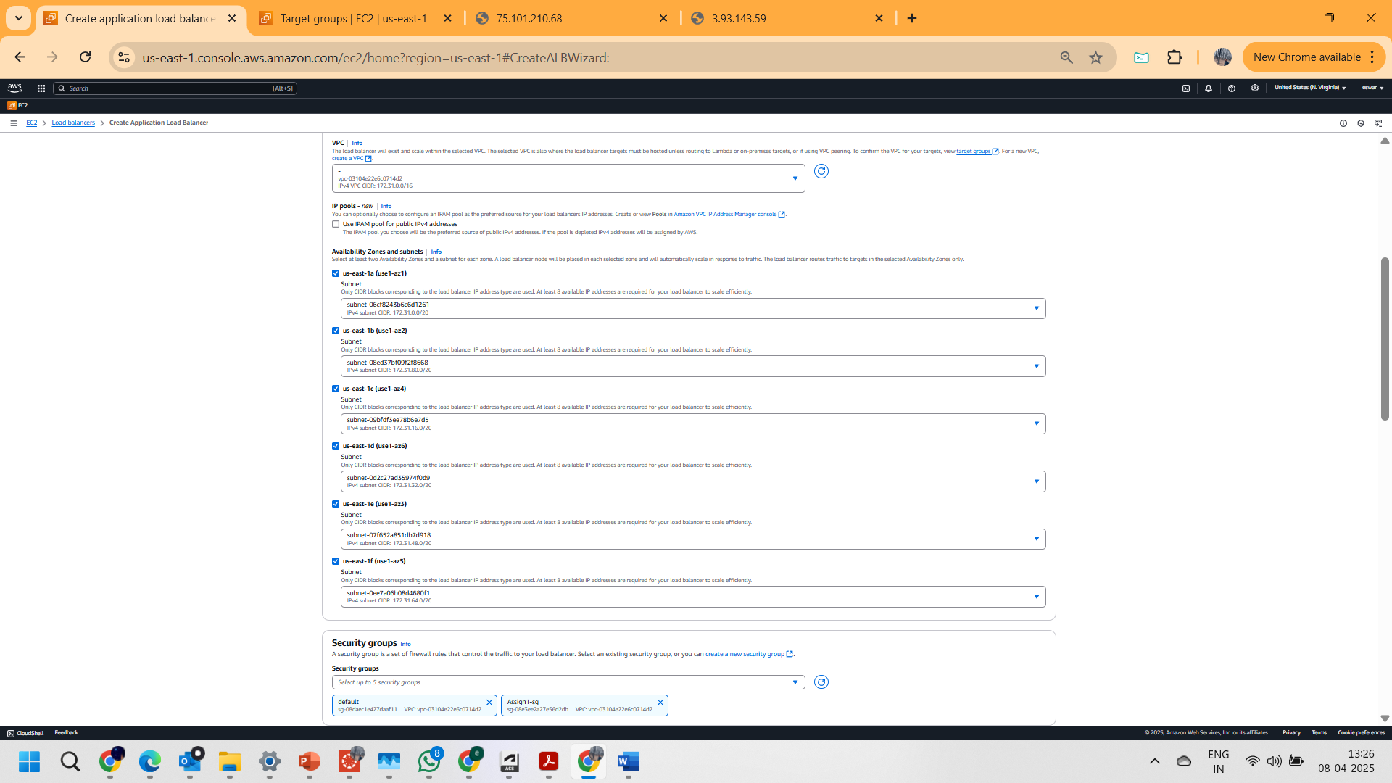

5.Selected **web-tg** from the dropdown in Listeners and routing.

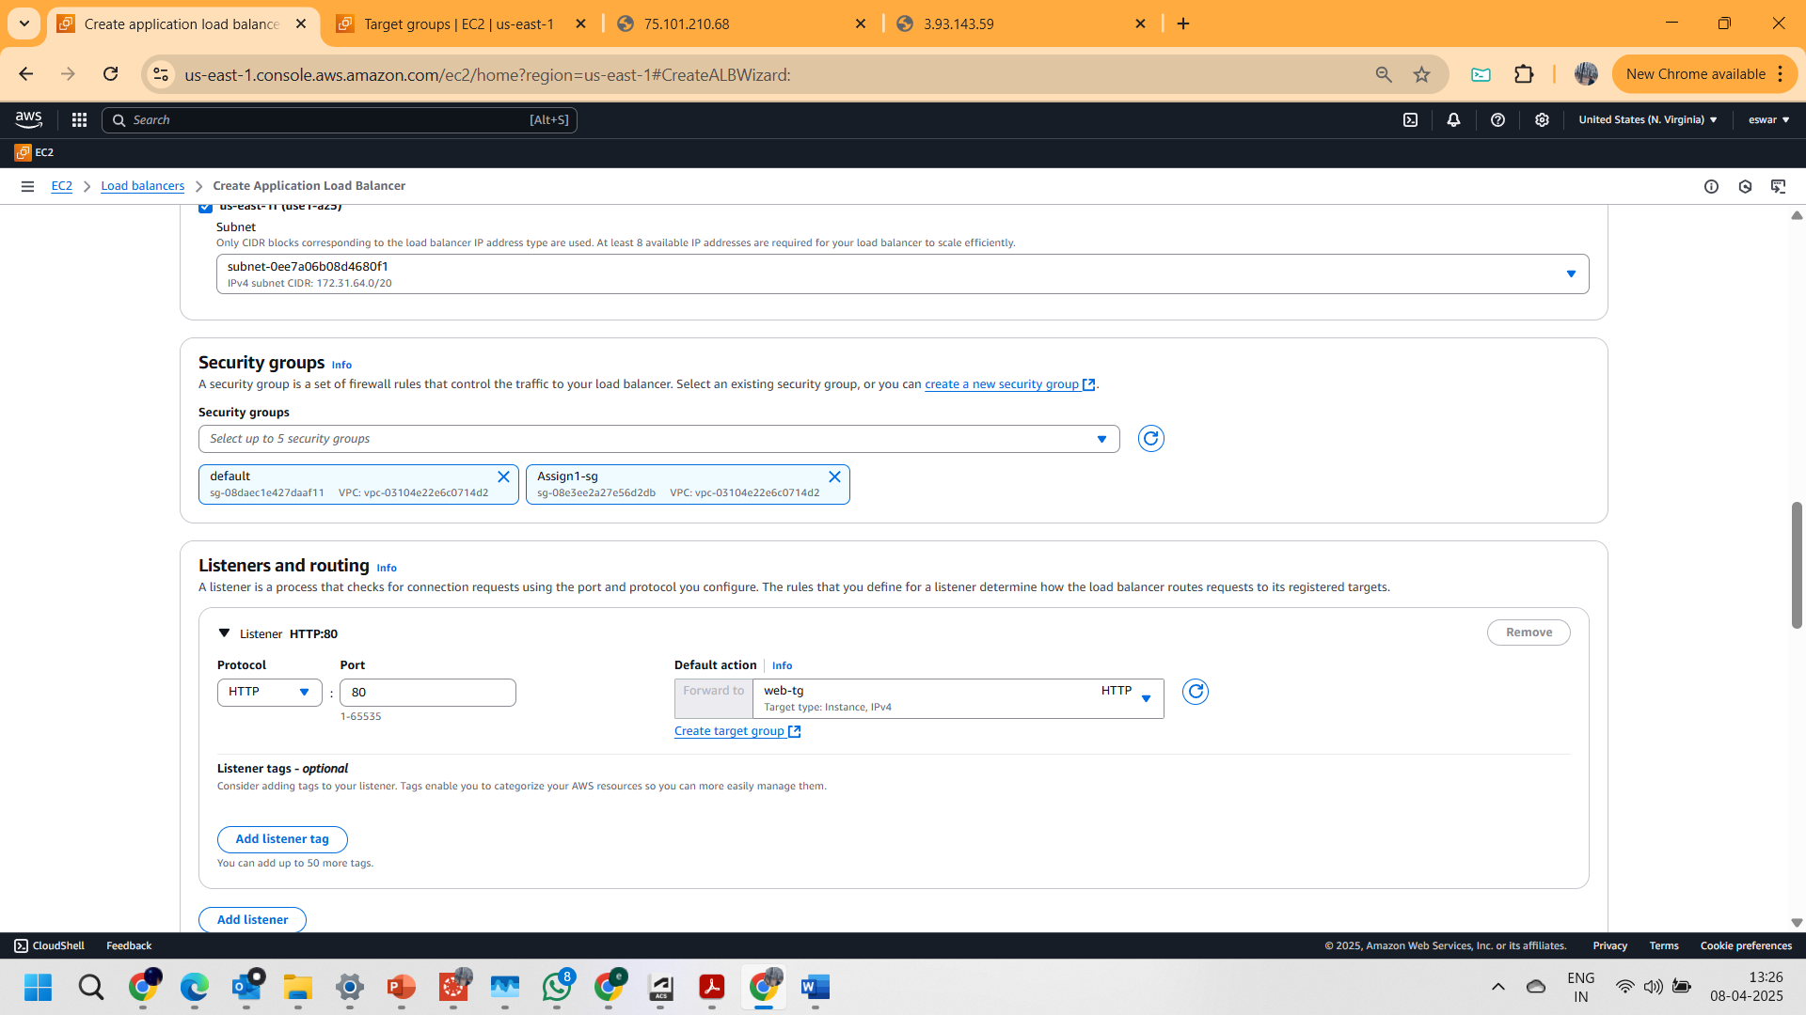

6. created a Load balancer as shown below.

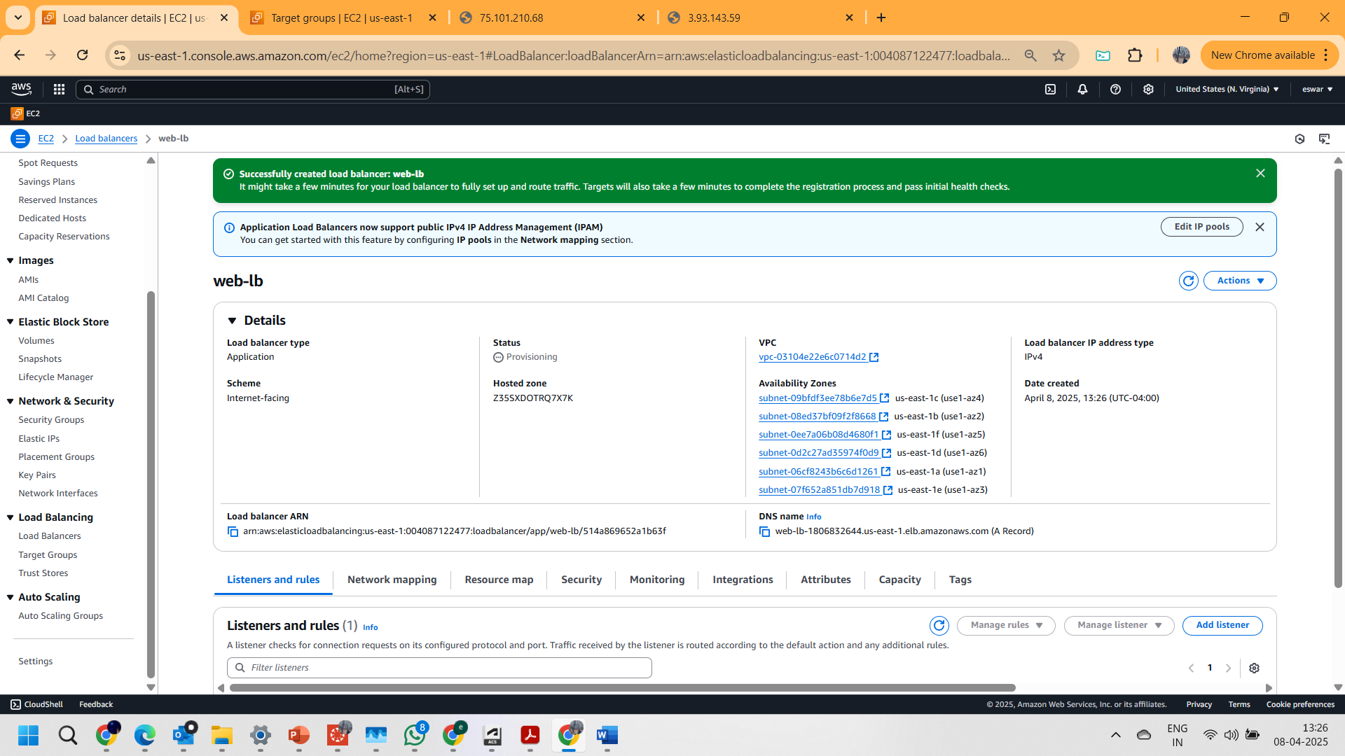

7. And Copied the DNS name of Load balancer and browsed in internet   
(http:// web-lb-1806832644.us-east-1.elb.amazonaws.com) and seen the results that..the IP address is changing when refreshing ..(captured the screenshots updated below)

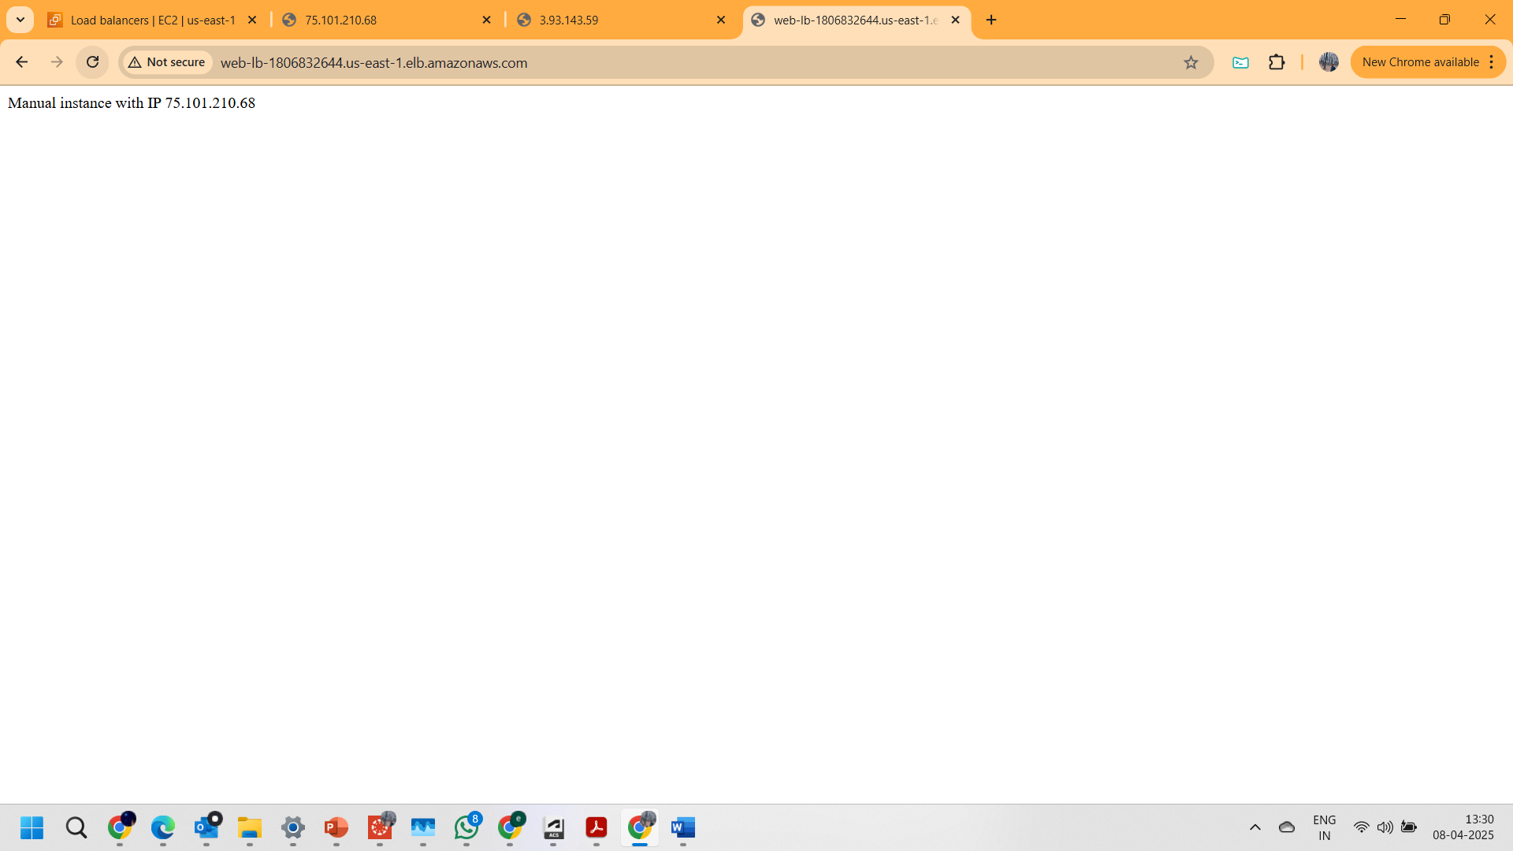

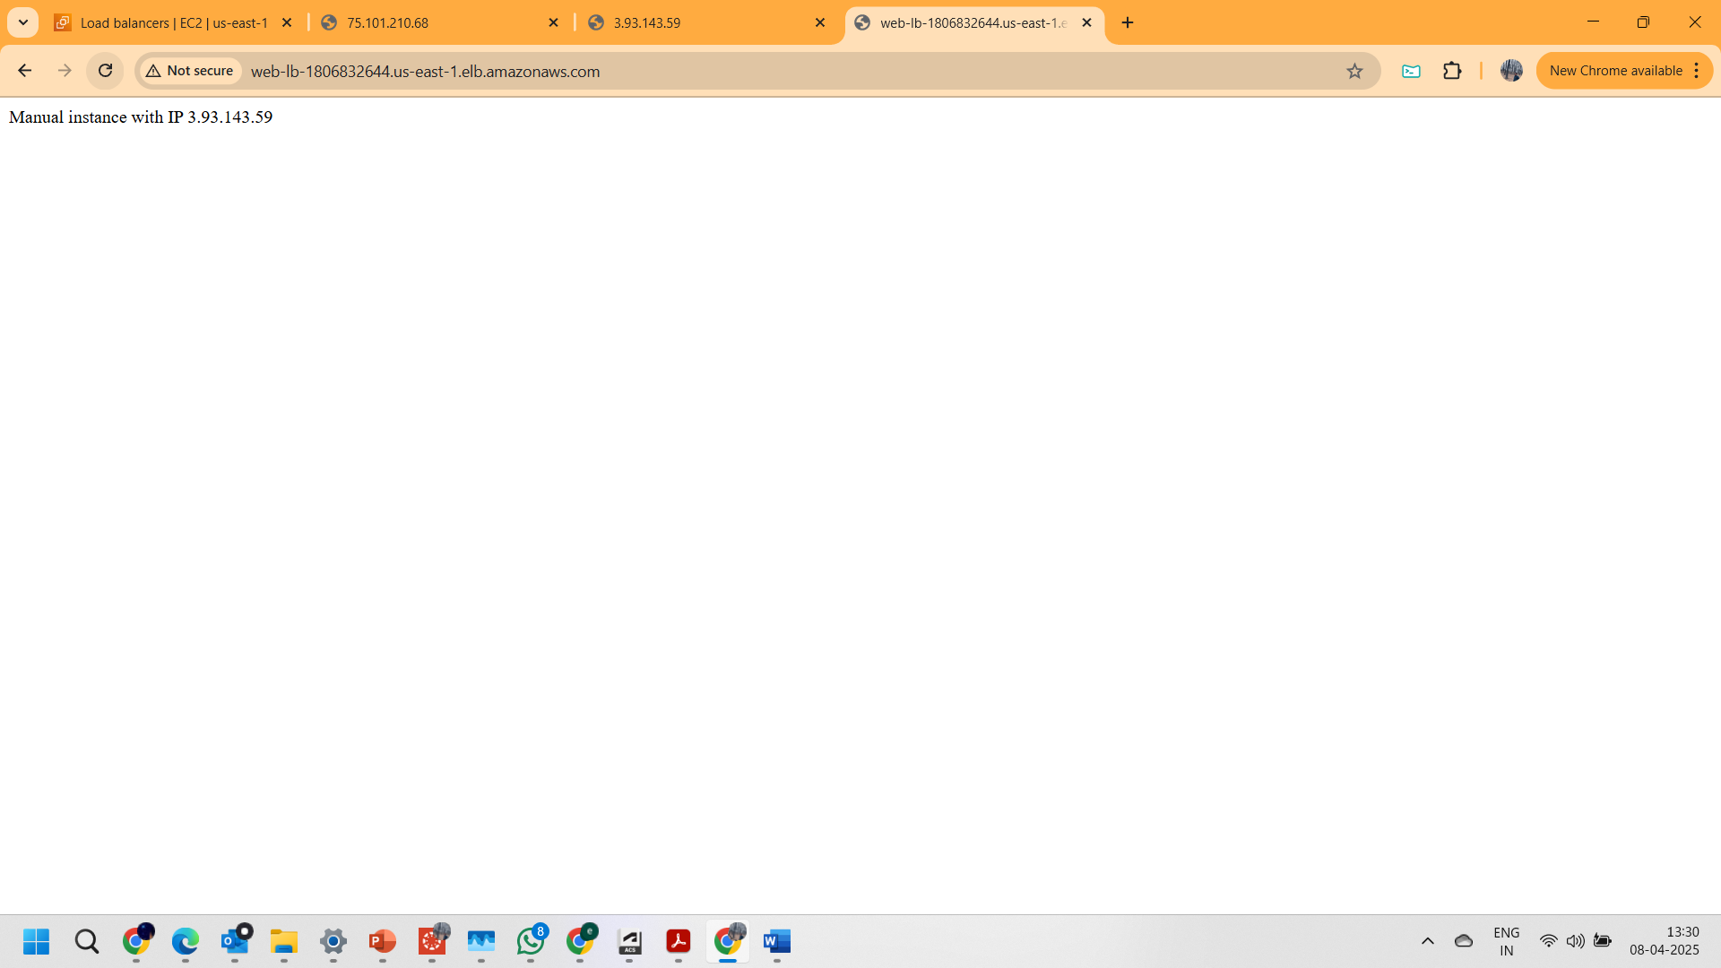

**Part 2: Create a Launch Template (LT)**

1. Opened the **Launch Template** page under instances section

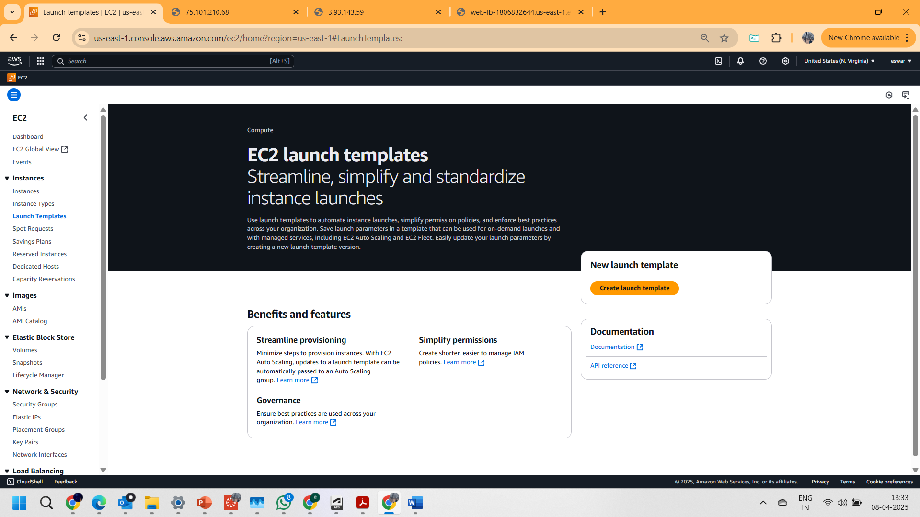

2.Given “**web-lt**” has Launch template name and added “**Web application launch template v1**” has Template Version Description. And checked Auto Scaling Guidance  
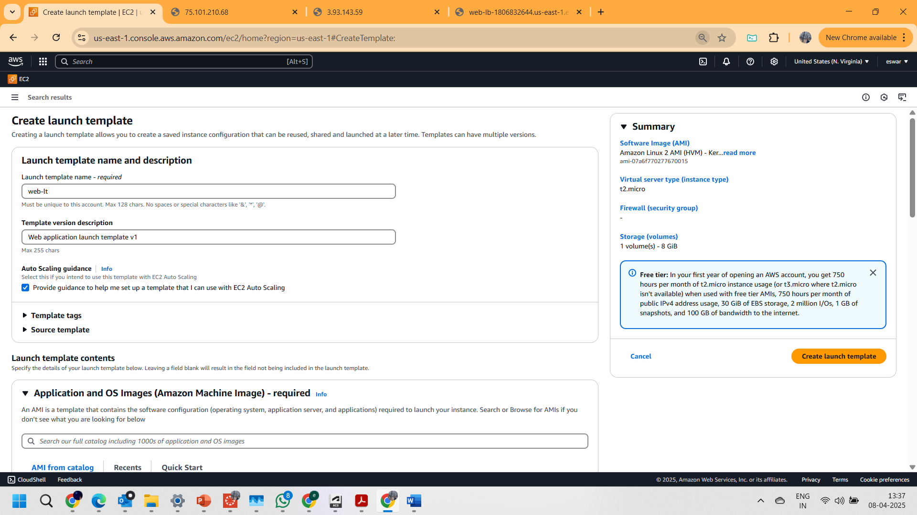

3. Chosen AMAZON LINUX AMI as Amazon machine image,  
selected t2. micro as instance type (free tier) and considered existing key pair.  
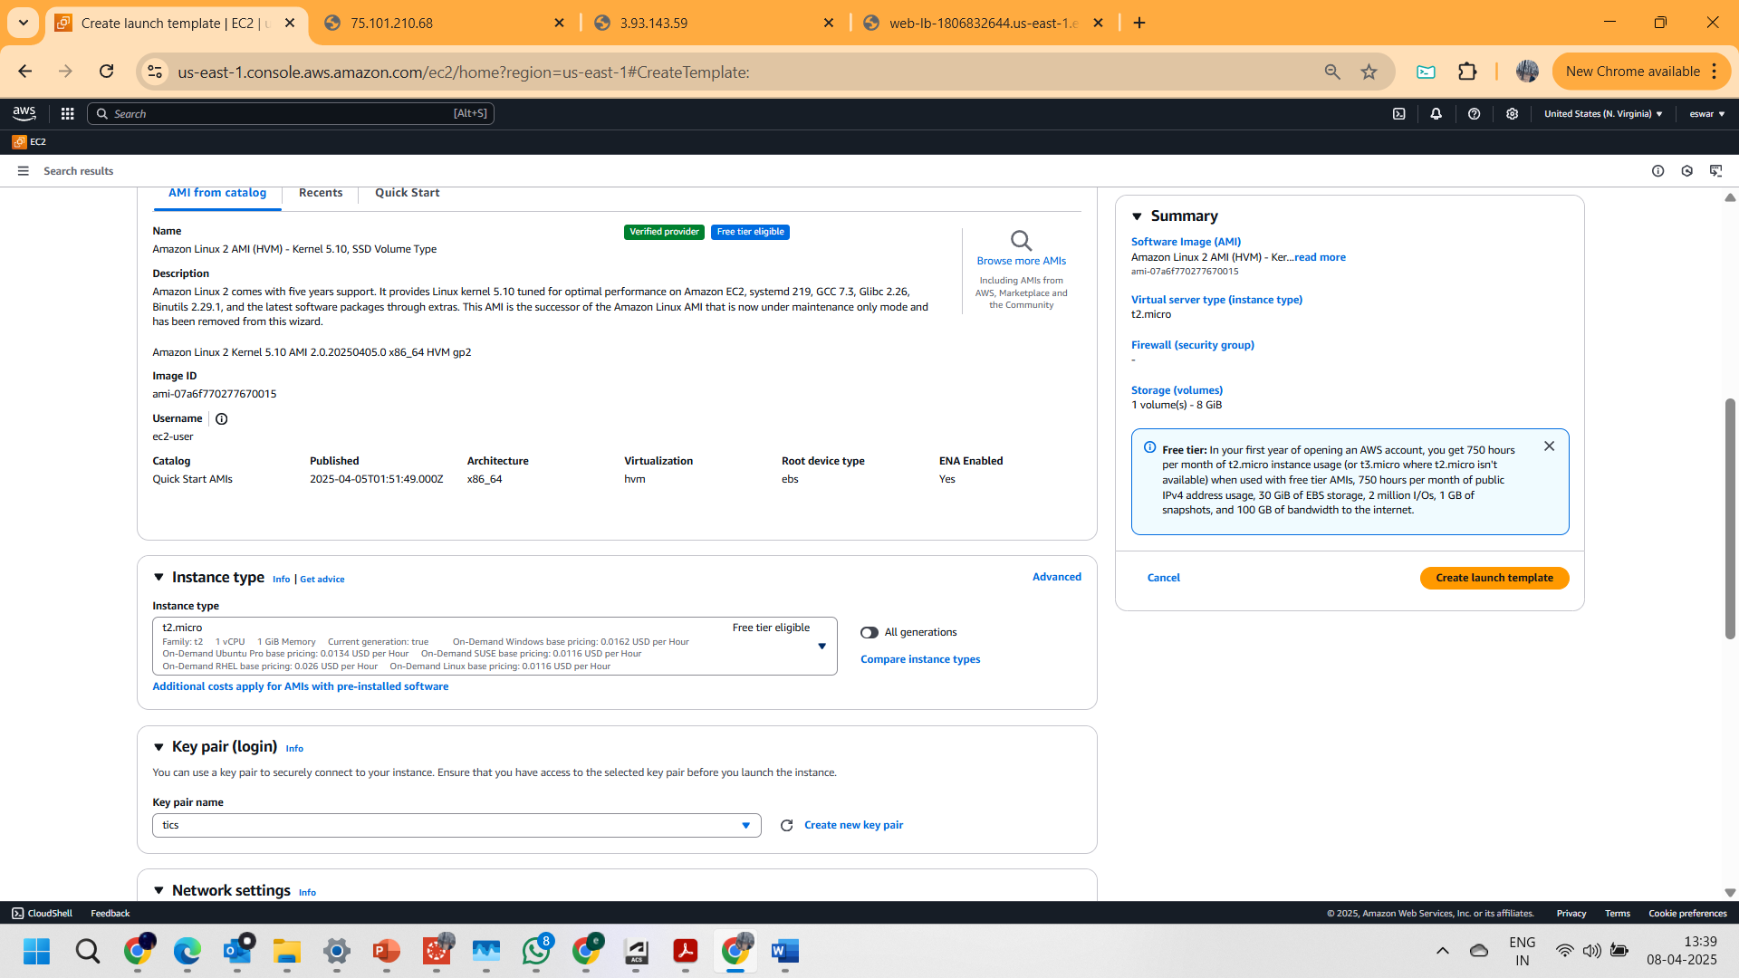

4.Selected existing security group “Assign1-sg”  
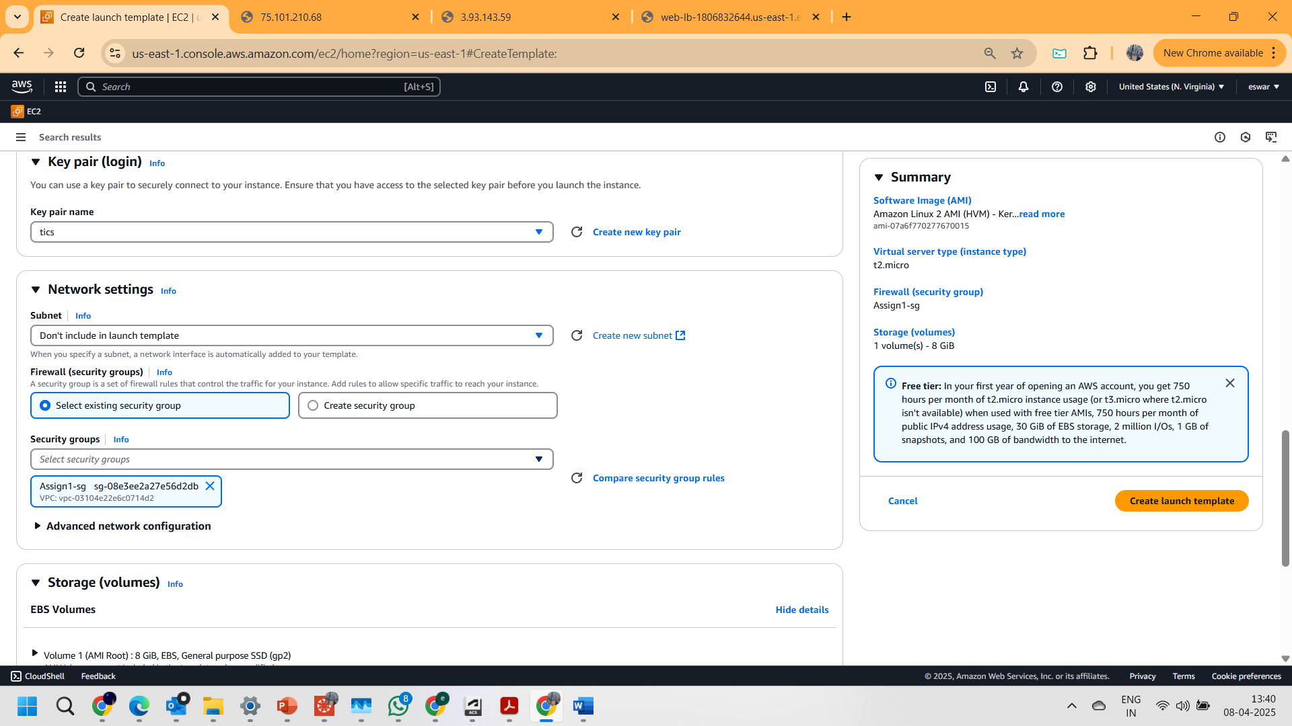

5. Pasted the bash script as shown below  
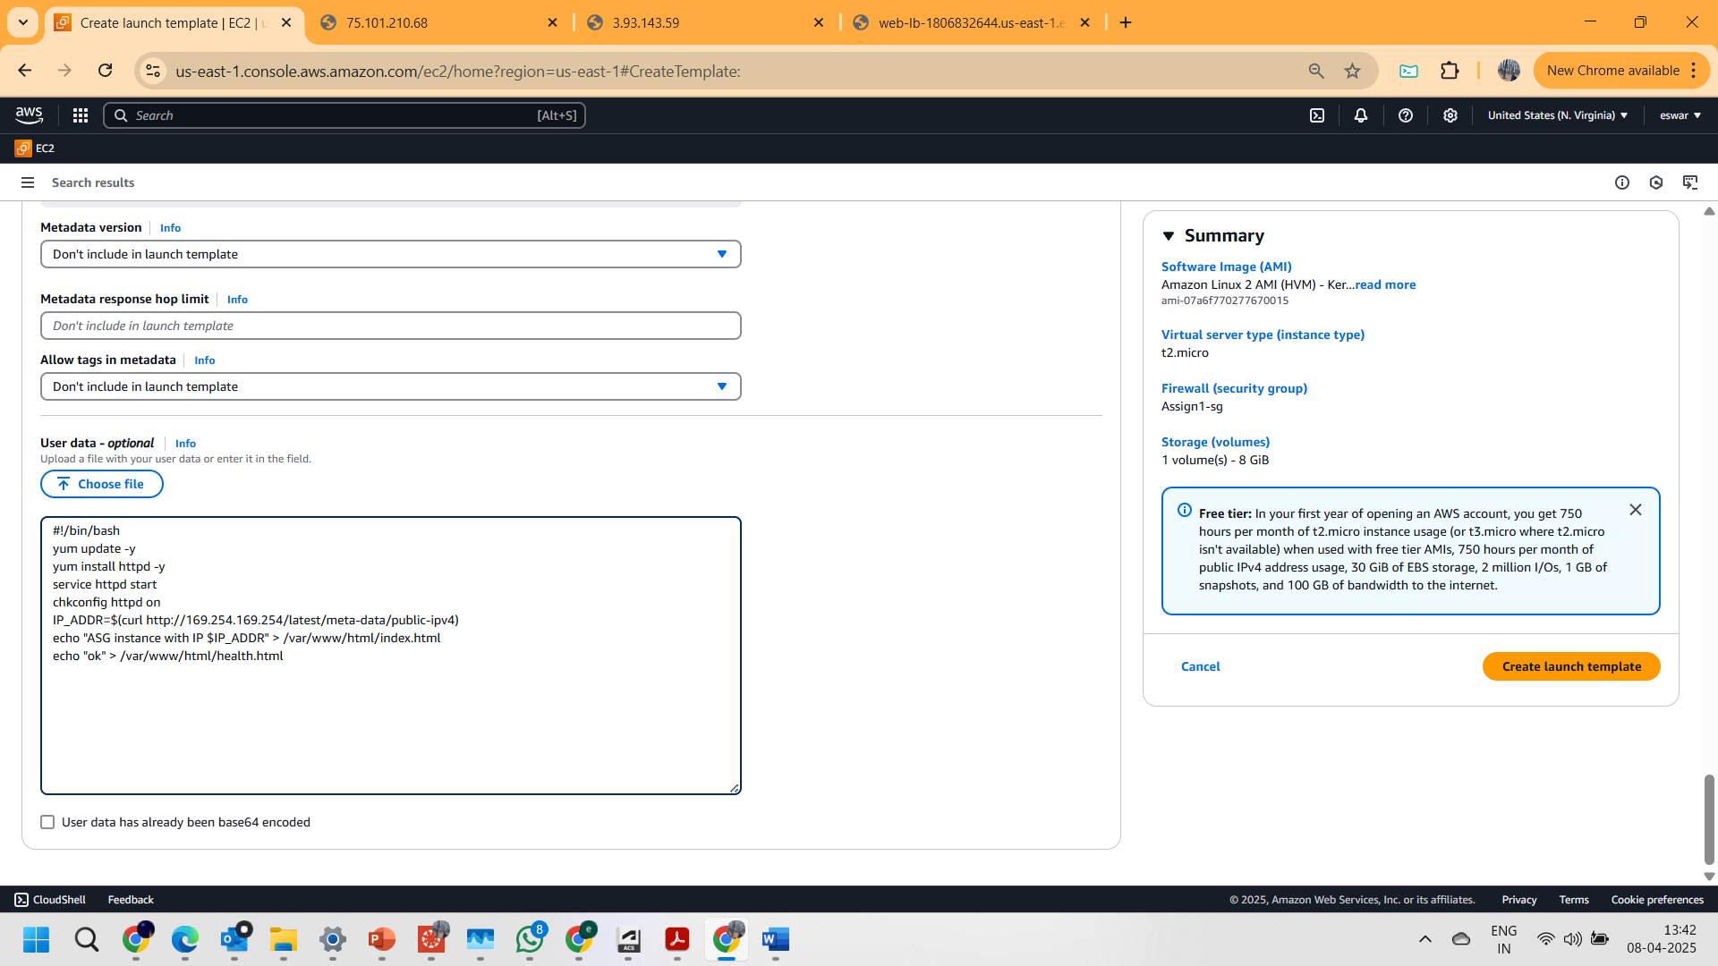

6.Launch template was successfully created  
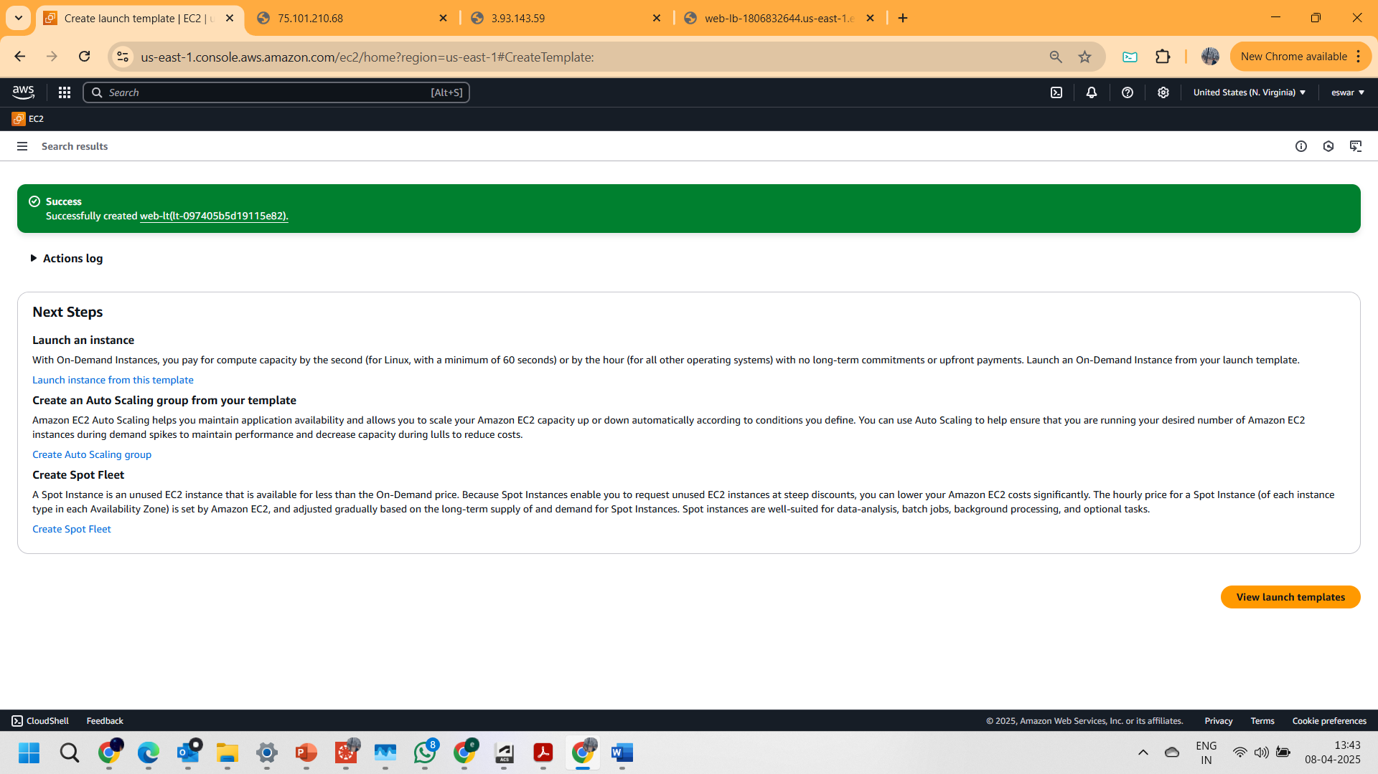

**Part 3: Create the Auto Scaling Group (ASG)**

**1.**Opened the Auto scaling group feature under EC2 features  
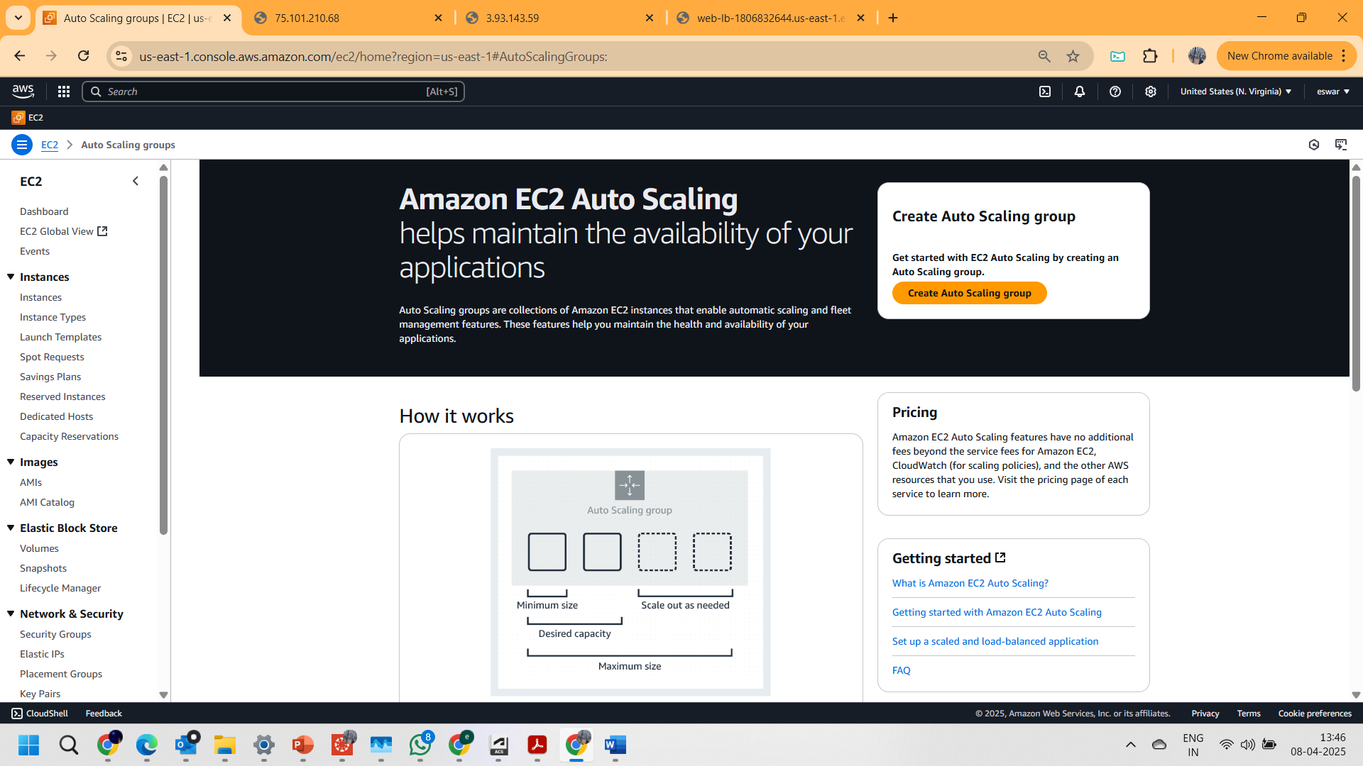

Step 1: **Choose launch template**

Given **web-asg** as auto scaling group name and chosen **web-lt** as launch template from dropdown  
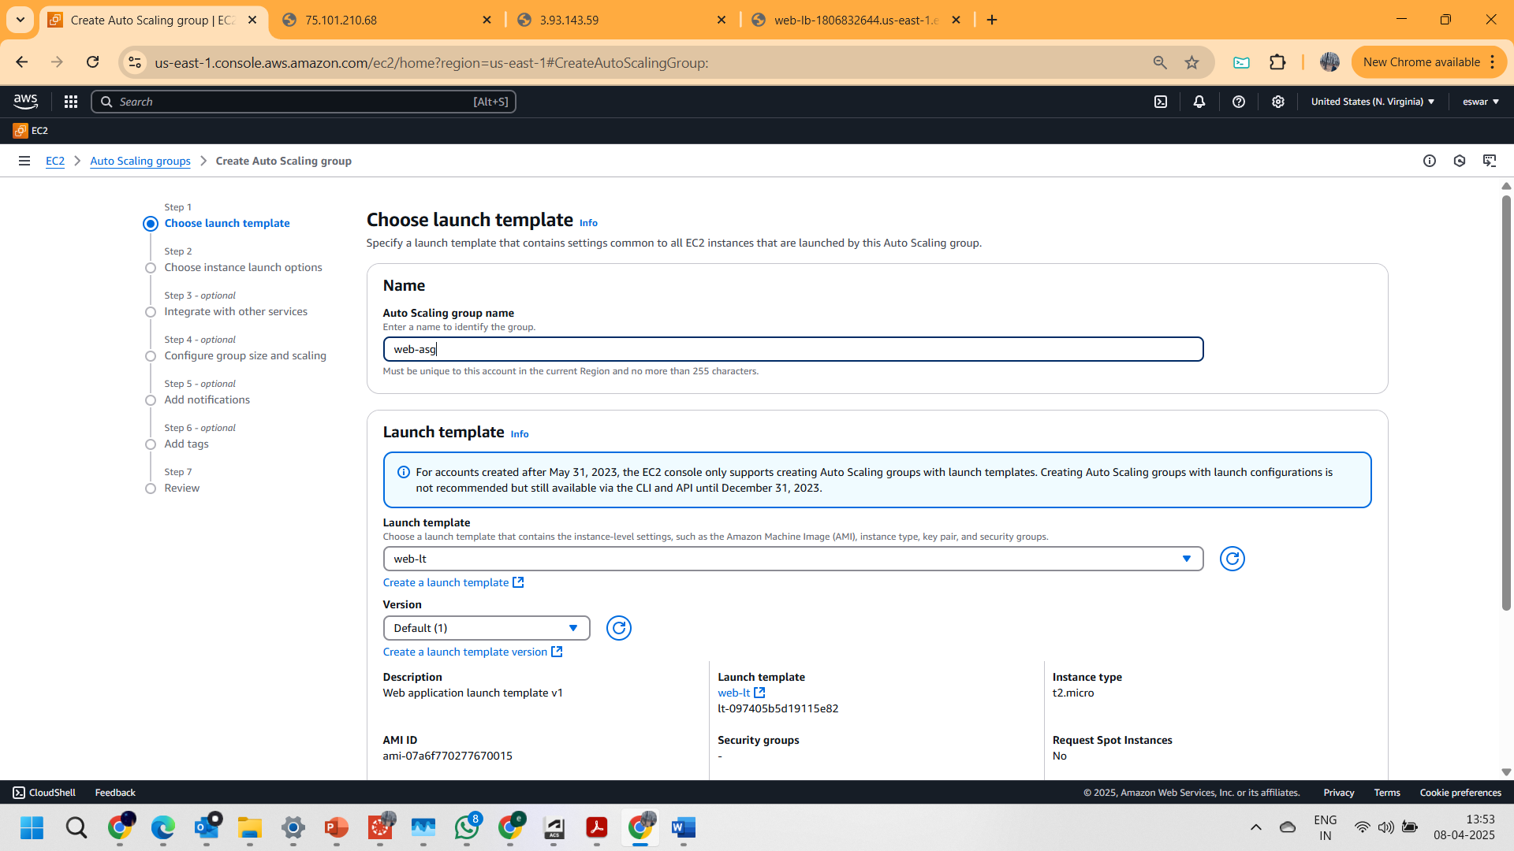

Step 2: **Choose instance launch options**

Ensured the default VPC is selected and checked the all-available Zones one by one as shown below  
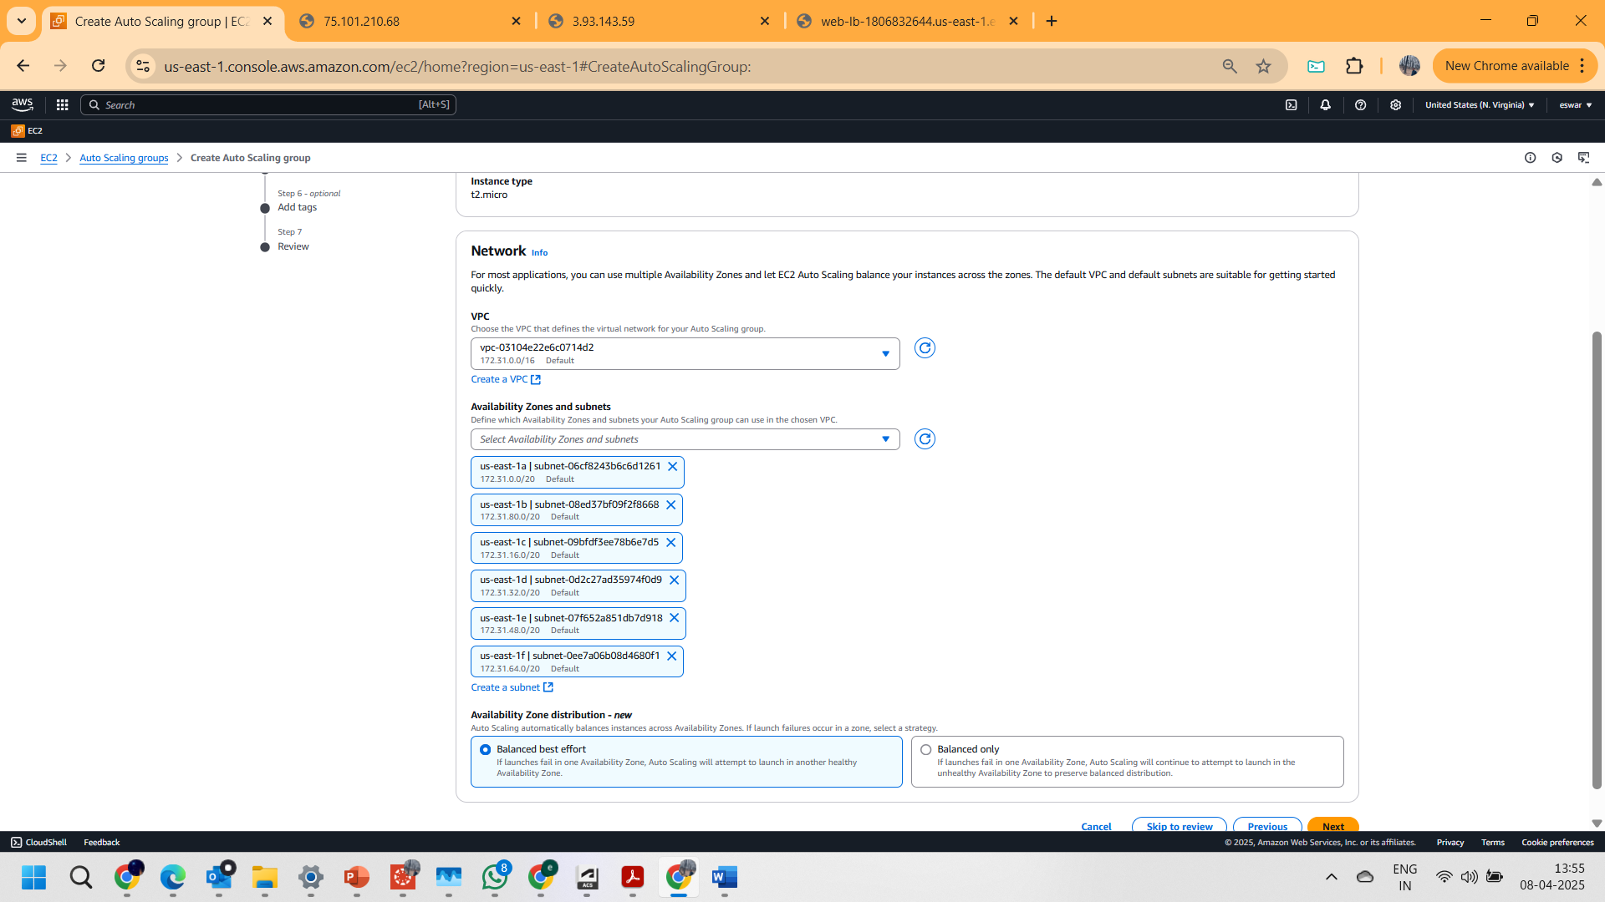

Step 3: **Configure advanced options**

1. Chosen “**Attach to an existing load balancer**” under Load Balancing card.  
and selected web-tg from dropdown.  
  
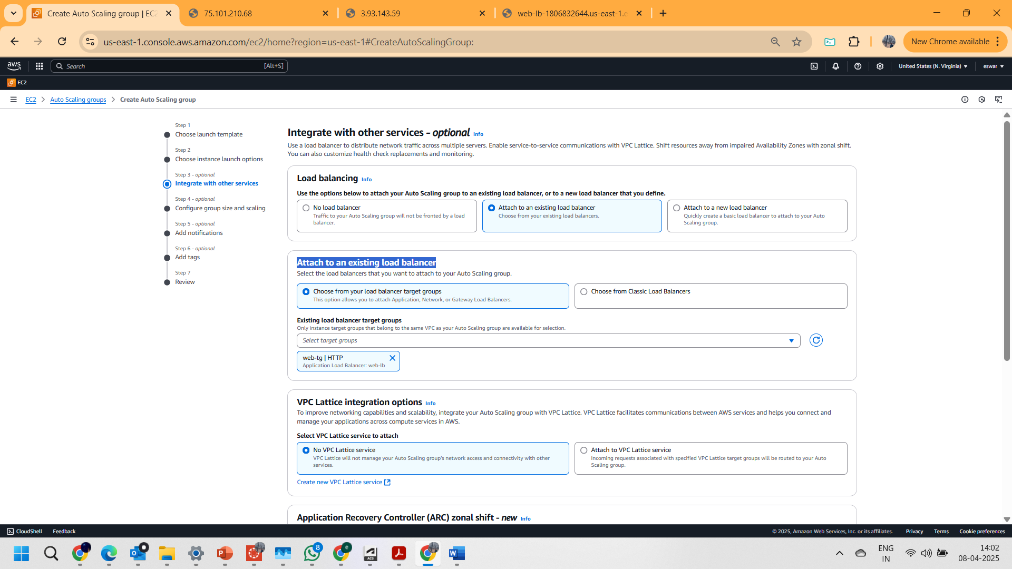

1. Under the Health checks card set the **health check grace period field** value to 180

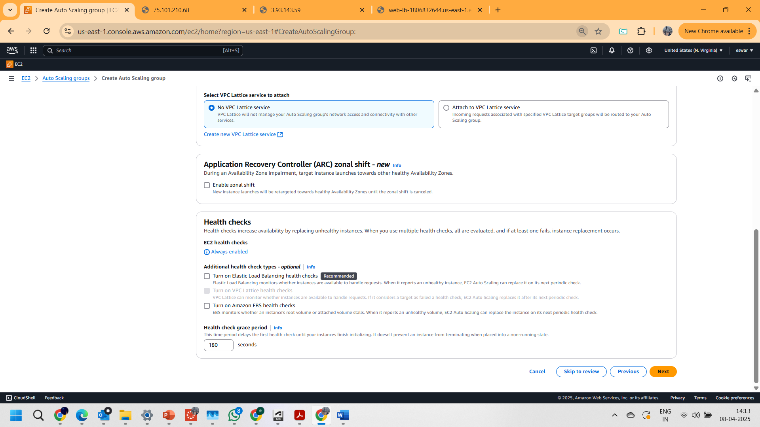

Step 4: **Configure group size and scaling policies**

* Changed the **desired capacity** to 2 in Group size Card
* Chosen “**Target tracking scaling policy**” under scaling
* Updated target value:80 and instance warmup:180  
    
  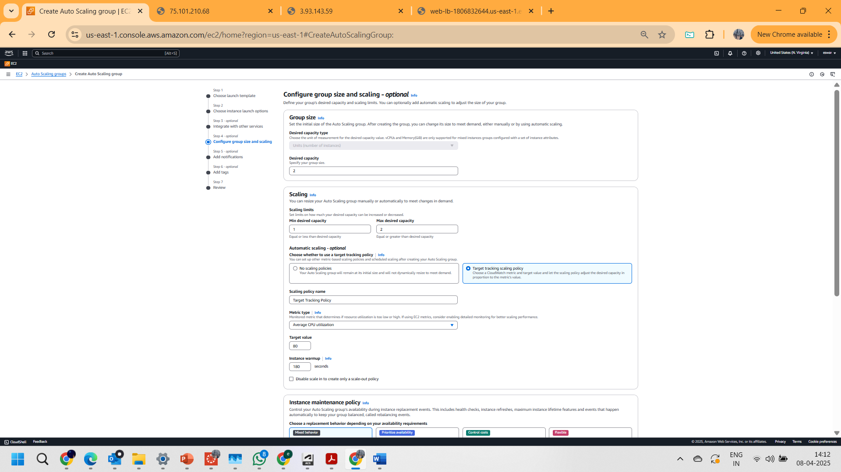

Step 5: **Add Notifications**  
Add notification, nothing to change  
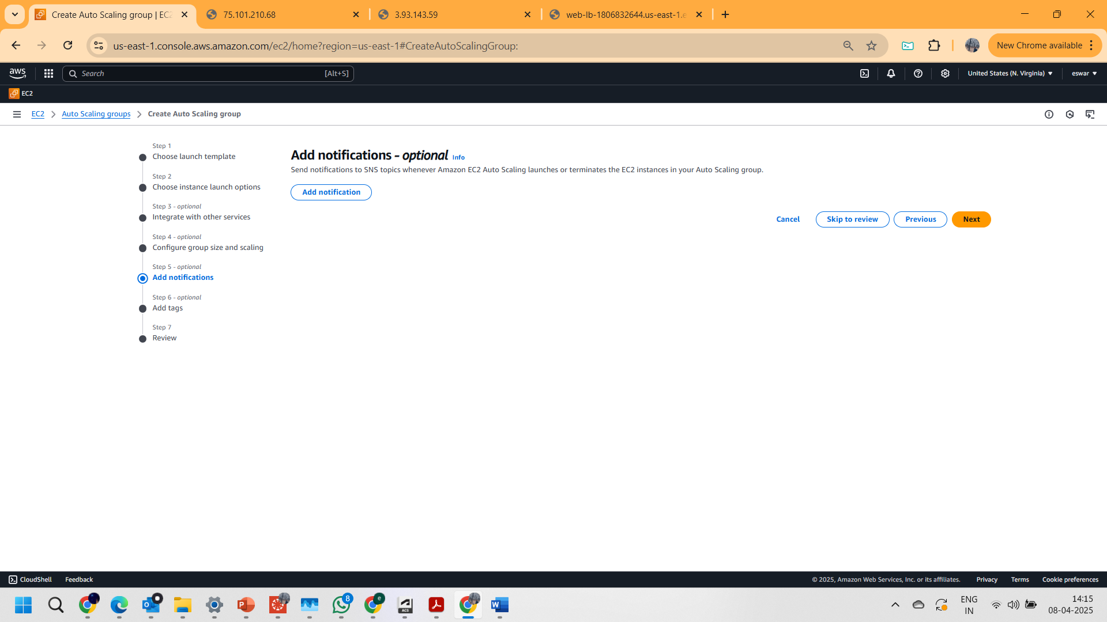

Step 6: **Add Tags**  
Give   
**Key:** Name   
**Value – optional:** asg-instance  
  
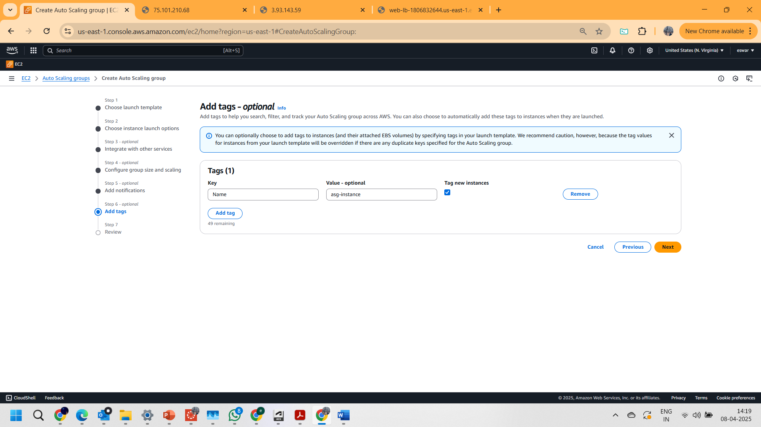

step 7: **Review**  
  
created Auto scaling group  
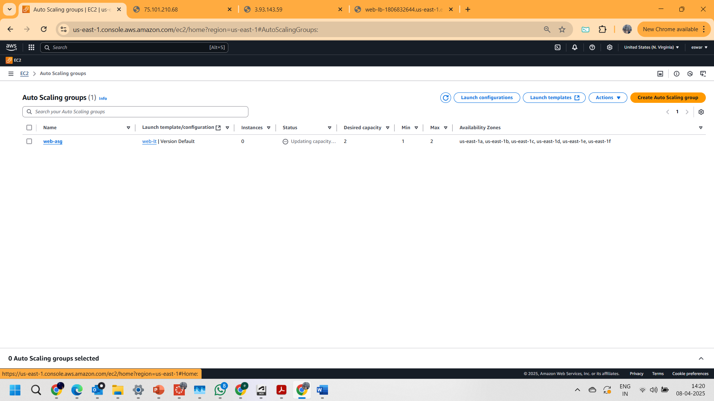

**Result**Observed the page text changing when constantly refreshing the Load Balancer DNS: http://web-lb-1806832644.us-east-1.elb.amazonaws.com/  
shown below  
  
 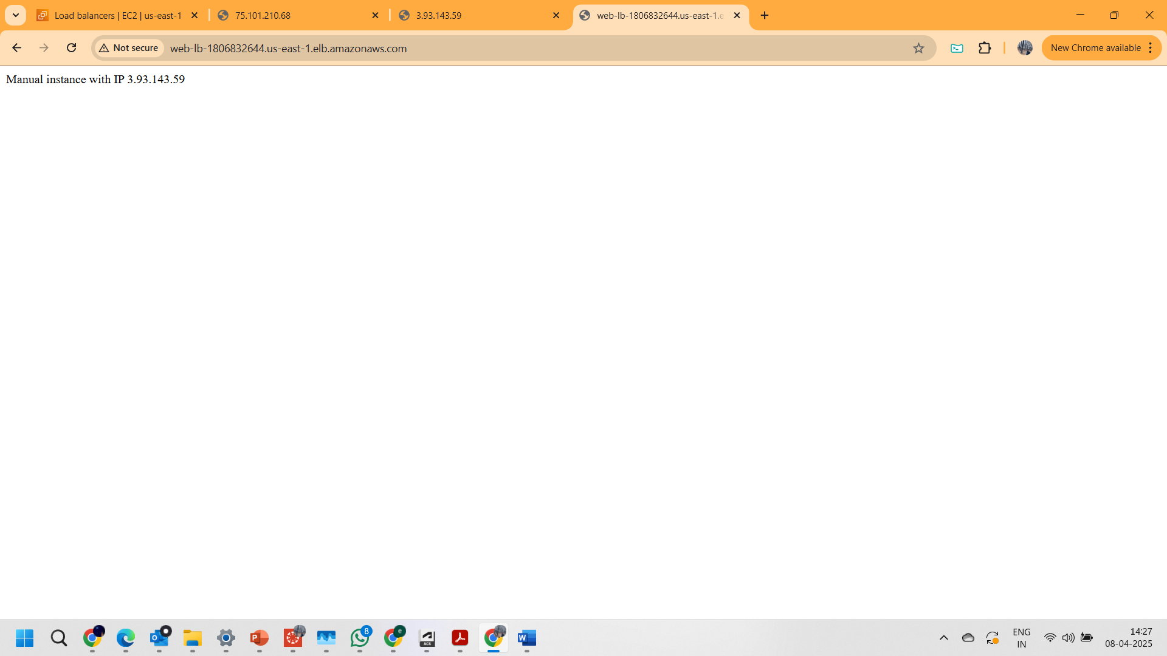

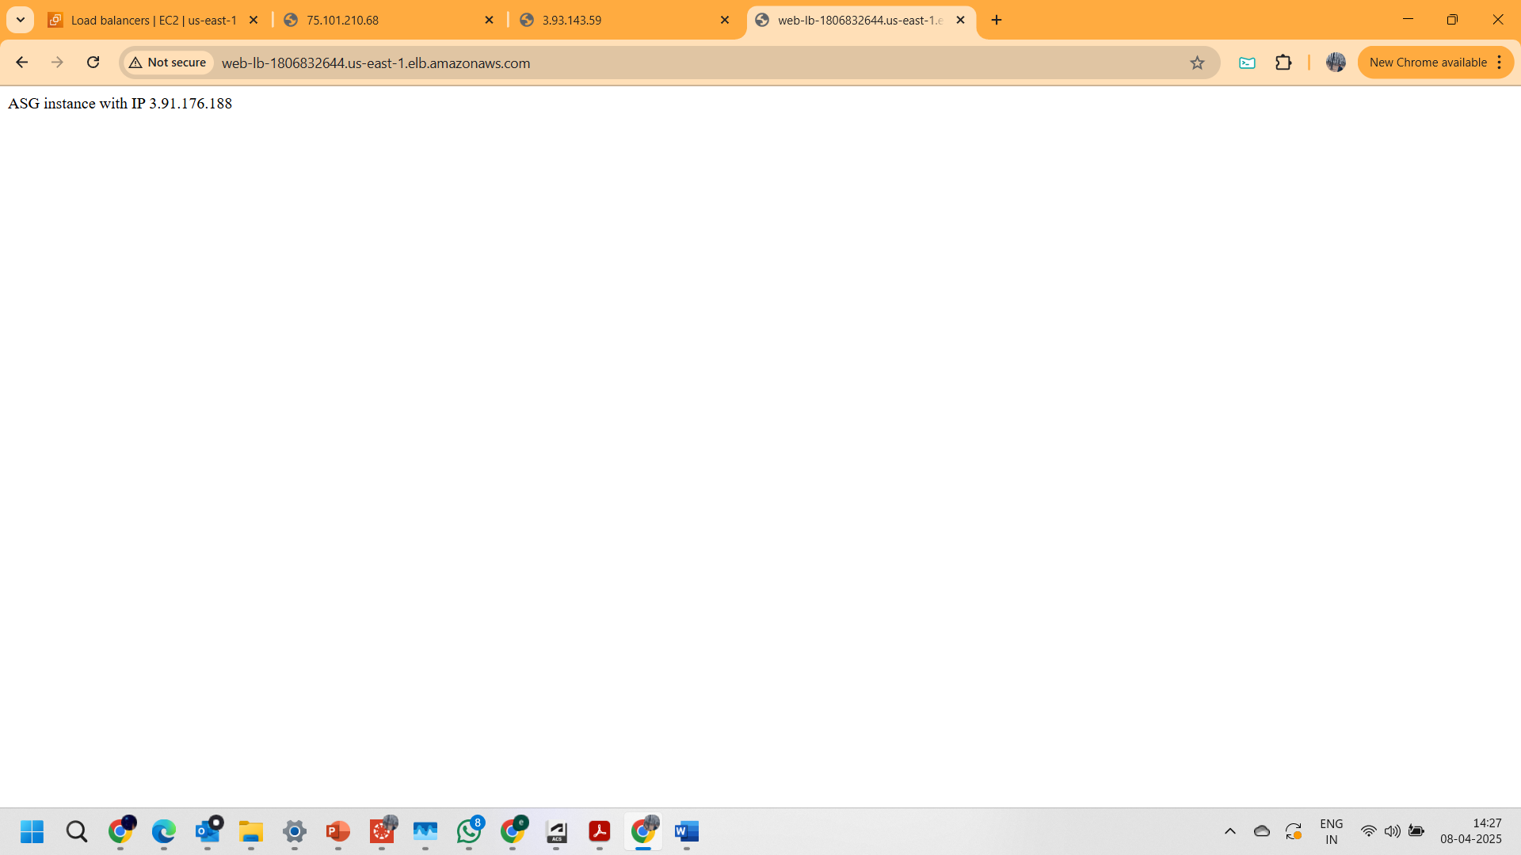

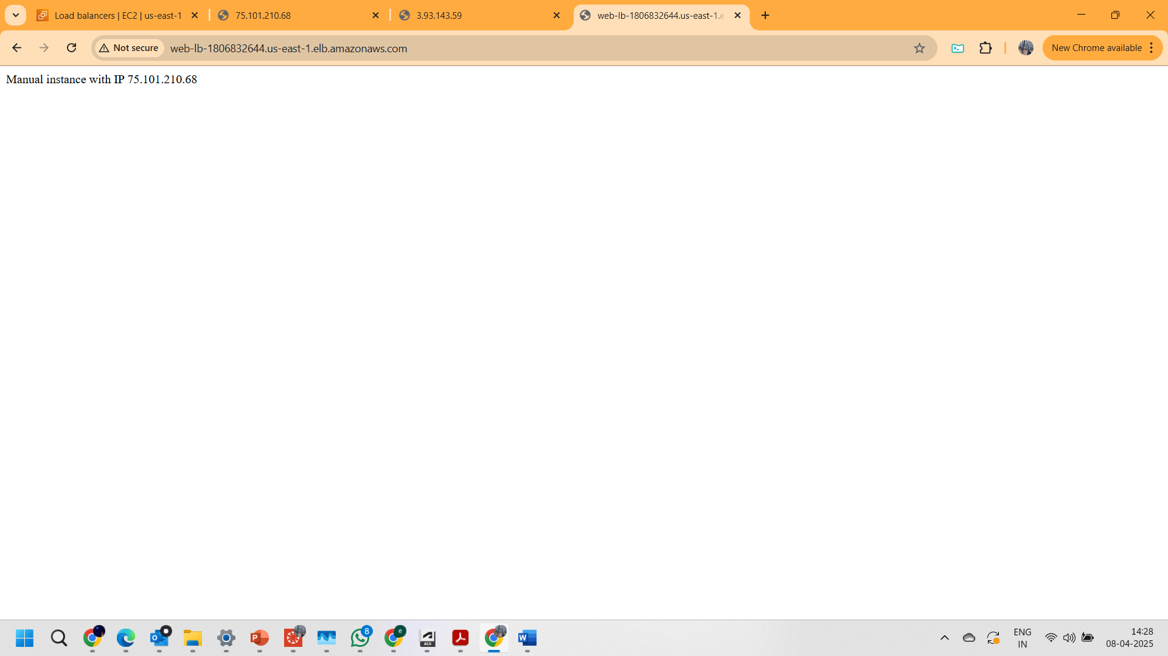

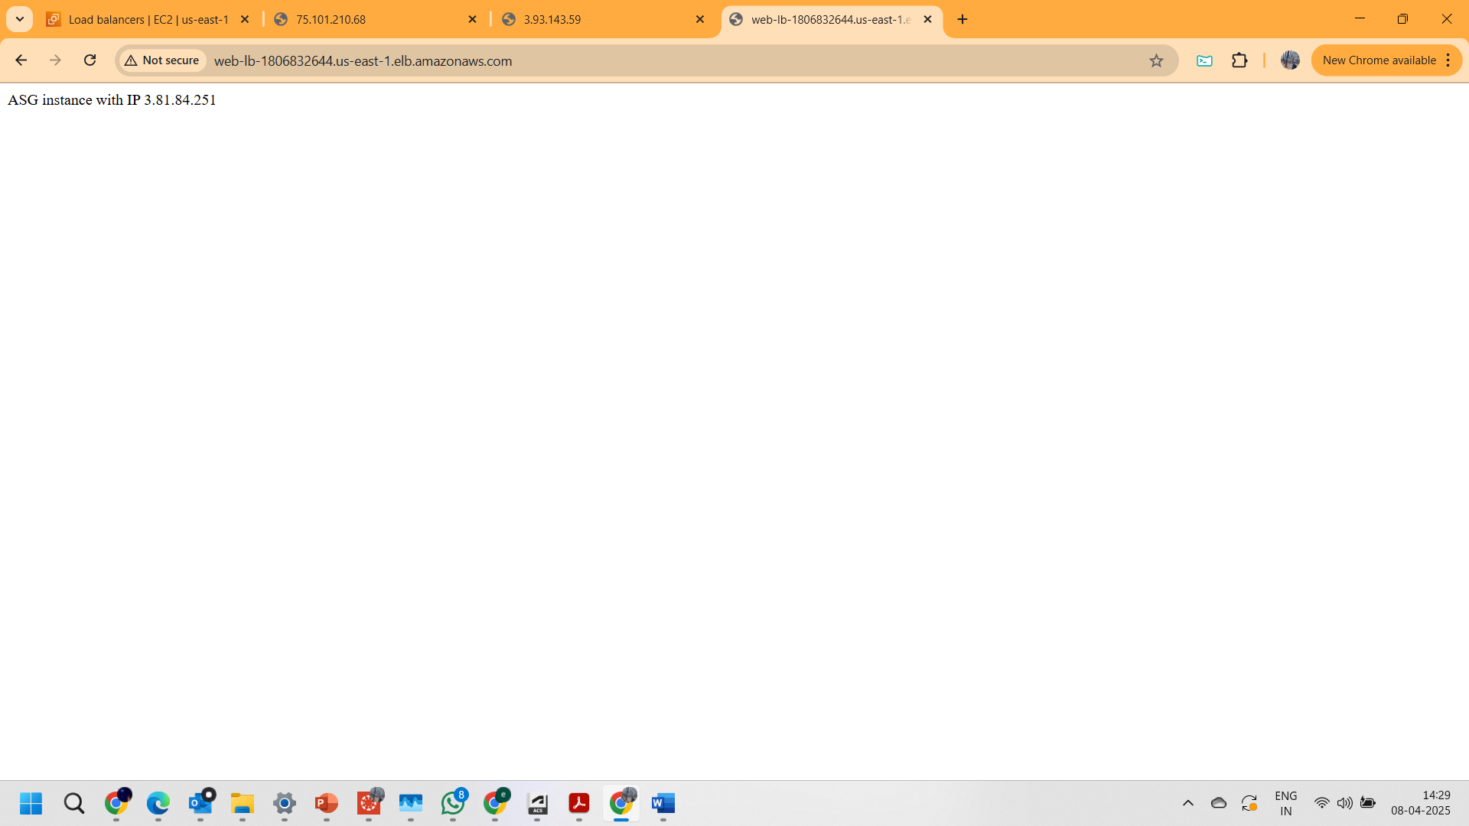

**PART 5: DELETING THE INSTANCES**

1. Terminated all the instances from AWS EC2 console as shown below.

